# Spring Certification Course

# 1. Module 01 – Container, Dependency and IoC

## 1.1 Question 01 - What is dependency injection and what are the advantages?

Dependency Injection is a technique of creating software in which objects do not create their dependencies on itself, instead objects declare dependencies that they need and it is external object job or framework job to provide concrete dependencies to objects.

Types of Dependency Injection:

*  Constructor injection
*  Setter injection
*  Interface injection

Advantages of using dependency injection is:

*  Increases code reusability
*  Increases code readability
*  Increases code maintainability
*  Increases code testability
*  Reduces coupling
*  Increases cohesion

### Common Classes

**public interface SalaryReport** {  
 **void** writeReport(**List**<**EmployeeSalary**> employeeSalaries);  
}

*@Component  
@Profile*("pdf-reports")  
**public class PdfSalaryReport implements SalaryReport** {  
 **public void** writeReport(**List**<**EmployeeSalary**> employeeSalaries) {  
 **System**.***out***.println("Writing Pdf Report");  
 }  
}

*@Component  
@Profile*("xls-reports")  
**public class XlsSalaryReport implements SalaryReport** {  
 **public void** writeReport(**List**<**EmployeeSalary**> employeeSalaries) {  
 **System**.***out***.println("Writing Xls Report");  
 }  
}

### 1.1.2 No Dependency Injection

**class EmployeesSalariesReportService** {  
 **void** generateReport() {  
 **EmployeeDao** employeeDao = **new** EmployeeDao();  
 **List**<**Employee**> employees = employeeDao.findAll();  
  
 **EmployeeSalaryCalculator** employeeSalaryCalculator = **new** EmployeeSalaryCalculator();  
 **List**<**EmployeeSalary**> employeeSalaries = employeeSalaryCalculator.calculateSalaries(employees);  
  
 **PdfSalaryReport** pdfSalaryReport = **new** PdfSalaryReport();  
 pdfSalaryReport.writeReport(employeeSalaries);  
 }  
}

**public class Runner** {  
 **public static void** main(**String**... args) {  
 **EmployeesSalariesReportService** employeesSalariesReportService = **new** EmployeesSalariesReportService();  
  
 employeesSalariesReportService.generateReport();  
 }  
}

*@RunWith*(**MockitoJUnitRunner**.**class**)  
**public class EmployeesSalariesReportServiceTest** {  
  
 *@InjectMocks* **private EmployeesSalariesReportService** employeesSalariesReportService;  
  
 *@Test* **public void** shouldGenerateSalaryReport() {  
  
 *// there is no way to write true unit test for this class,  
 // since there is now way to inject mocks,  
 // the only possibility without dependency injection  
 // is to write integration test* }  
}

### 1.1.2 Manual Dependency Injection

**class EmployeesSalariesReportService** {  
 **private final EmployeeDao** employeeDao;  
 **private final EmployeeSalaryCalculator** employeeSalaryCalculator;  
 **private final SalaryReport** salaryReport;  
  
 EmployeesSalariesReportService(**EmployeeDao** employeeDao, **EmployeeSalaryCalculator** employeeSalaryCalculator, **SalaryReport** salaryReport) {  
 **this**.employeeDao = employeeDao;  
 **this**.employeeSalaryCalculator = employeeSalaryCalculator;  
 **this**.salaryReport = salaryReport;  
 }  
  
 **void** generateReport() {  
 **List**<**Employee**> employees = employeeDao.findAll();  
 **List**<**EmployeeSalary**> employeeSalaries = employeeSalaryCalculator.calculateSalaries(employees);  
  
 salaryReport.writeReport(employeeSalaries);  
 }  
}

**public class Runner** {  
 **public static void** main(**String**... args) {  
 **EmployeesSalariesReportService** employeesSalariesReportService = **new** EmployeesSalariesReportService(  
 **new** EmployeeDao(),  
 **new** EmployeeSalaryCalculator(),  
 **new** PdfSalaryReport()  
 );  
  
 employeesSalariesReportService.generateReport();  
 }  
}

*@RunWith*(**MockitoJUnitRunner**.**class**)  
**public class EmployeesSalariesReportServiceTest** {  
 *@InjectMocks* **private EmployeesSalariesReportService** employeesSalariesReportService;  
 *@Mock* **private EmployeeDao** employeeDao;  
 *@Mock* **private EmployeeSalaryCalculator** employeeSalaryCalculator;  
 *@Mock* **private SalaryReport** salaryReport;  
 *@Mock* **private List**<**Employee**> employees;  
 *@Mock* **private List**<**EmployeeSalary**> employeeSalaries;  
  
 *@Test* **public void** shouldGenerateSalaryReport() {  
 *when*(employeeDao.findAll()).thenReturn(employees);  
 *when*(employeeSalaryCalculator.calculateSalaries(employees)).thenReturn(employeeSalaries);  
  
 employeesSalariesReportService.generateReport();  
  
 *verify*(salaryReport).writeReport(employeeSalaries);  
 }  
}

### Spring Dependency Injection

*@ComponentScan*("com.spring.professional.exam.tutorial.module01.question01")  
**public class Configuration** {  
}

*@Service***class EmployeesSalariesReportService** {  
 **private final EmployeeDao** employeeDao;  
 **private final EmployeeSalaryCalculator** employeeSalaryCalculator;  
 **private final SalaryReport** salaryReport;  
  
 EmployeesSalariesReportService(**EmployeeDao** employeeDao, **EmployeeSalaryCalculator** employeeSalaryCalculator, **SalaryReport** salaryReport) {  
 **this**.employeeDao = employeeDao;  
 **this**.employeeSalaryCalculator = employeeSalaryCalculator;  
 **this**.salaryReport = salaryReport;  
 }  
  
 **void** generateReport() {  
 **List**<**Employee**> employees = employeeDao.findAll();  
 **List**<**EmployeeSalary**> employeeSalaries = employeeSalaryCalculator.calculateSalaries(employees);  
  
 salaryReport.writeReport(employeeSalaries);  
 }  
}

**public class Runner** {  
 **public static void** main(**String**... args) {  
 **AnnotationConfigApplicationContext** context = *getSpringContext*("xls-reports");  
  
 **EmployeesSalariesReportService** employeesSalariesReportService = context.getBean(**EmployeesSalariesReportService**.**class**);  
 employeesSalariesReportService.generateReport();  
  
 context.close();  
 }  
  
 **private static AnnotationConfigApplicationContext** getSpringContext(**String** profile) {  
 **AnnotationConfigApplicationContext** context = **new** AnnotationConfigApplicationContext();  
 context.getEnvironment().setActiveProfiles(profile);  
 context.register(**Configuration**.**class**);  
 context.refresh();  
 **return** context;  
 }  
}

## 1.2 Question 02 - What is a pattern? What is an antipattern? Is dependency injection a pattern?

A Software Design Pattern is a reusable solution to often, commonly occurring problem in software design. It is a high-level description on how to solve the problem, that can be used in many different situations. Design patterns often represent best practices that developers can use to solve common problems.

Some examples of commonly used design patterns from GoF Design Patterns:

*  Factory Method
*  Builder
*  Template Method
*  Strategy
*  Observer
*  Visitor
*  Facade
*  Composite

Dependency Injection is a pattern that solves problem of flexible dependencies creation.

Anti-pattern is ineffective and counter-productive solution to often occurring problem.

Examples of Anti-patterns in Object Oriented Programming:

*  God Object – big class with lot of responsibilities
*  Sequential coupling – one object calling another object but needs to do it in a particular order.
*  Circular dependency – A depends on B depends on C depends on A.
*  Constant interface – Define constants defined in Interface – expose them through the API!!

## 1.3 Question 03 - What is an interface and what are the advantages of making use of them in Java? Why are they recommended for Spring beans?

OOP Definition – An interface is a description of actions that object can do, it is a way to enforce actions on object that implements the interface Java Definition – An interface is a reference type, which contains collections of abstract method. Class that implements the interface, must implement all methods from this interface, or it needs to declare methods as abstract if object does not know how to implement specified method. Java Interface may contain also:

*  Constants
*  Default Methods (Java 8)
*  Static methods
*  Nested types

Advantages of using interfaces in Java:

*  Allows decoupling between contract and its implementation
*  Allows declaring contract between callee and caller
*  Increases interchangeability
*  Increases testability

Advantages of using interfaces in Spring:

*  Allows for use of JDK Dynamic Proxy – can only use this with interfaces
*  Allows implementation hiding – see example interface is public but implementations are package private so the implementation is hidden.
*  Allows to easily switch beans – use the @Qualifier annotation.

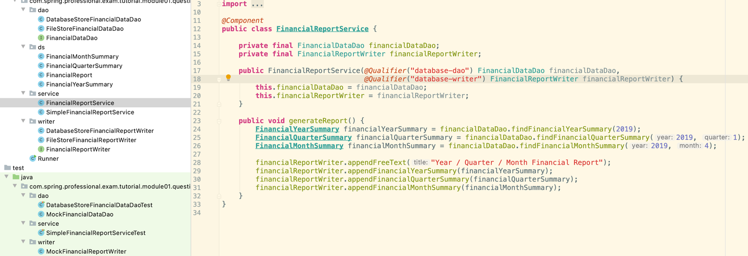

Note the interface is public but the implementations are default or package-private, but are still able to be accessed by Spring.

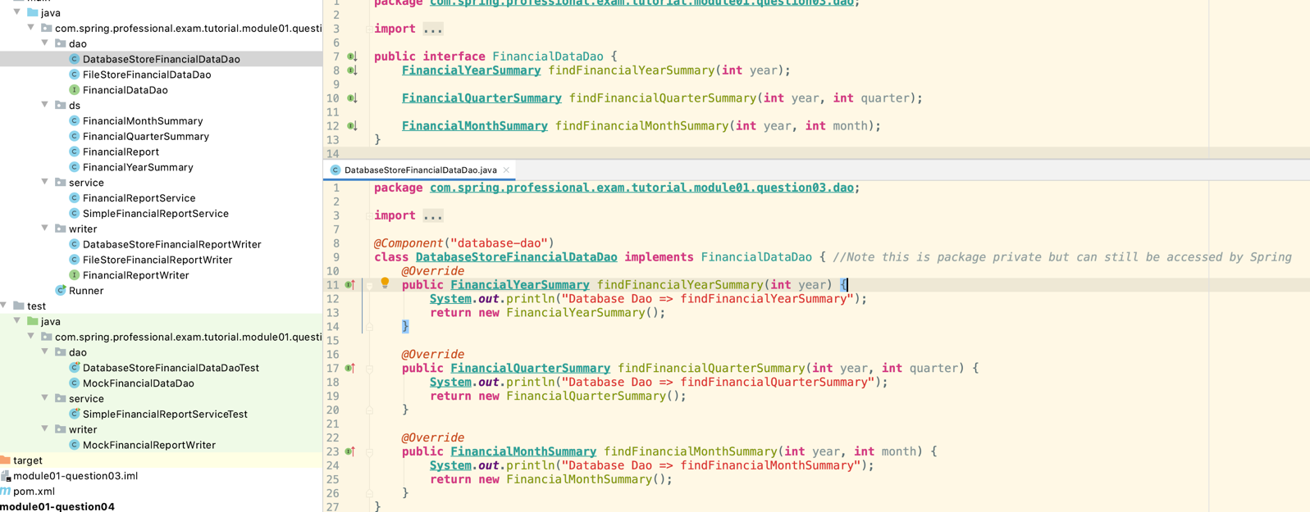

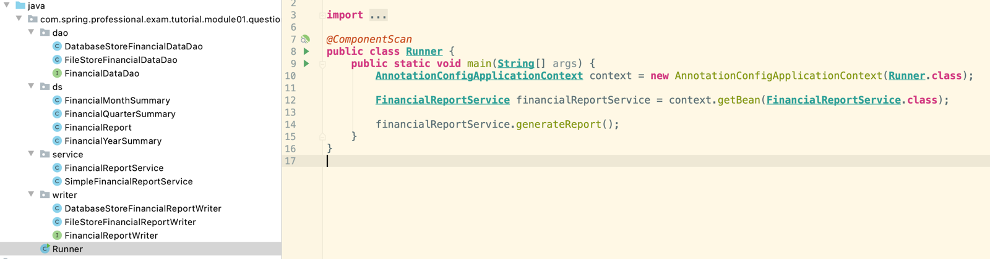

## 1.4 Question 04 - What is meant by “application-context”?

Application Context is a central part of Spring application. It holds bean definitions and contains registry of application components. It allows you to retrieve assembled and configured beans.

Application Context:

*  Initiates Beans
*  Configures Beans
*  Assemblies Beans
*  Manages Beans Lifecycle
*  Is a Bean Factory
*  Is a Resource Loader
*  Has ability to push events to registered even listeners
*  Exposes Environment which allows to resolve properties

Common Application Context types:

*  AnnotationConfigApplicationContext – general use.
*  AnnotationConfigWebApplicationContext – used for serverlets.
*  ClassPathXmlApplicationContext – use with xml.
*  FileSystemXmlApplicationContext – xml now exists within the filesystem.
*  XmlWebApplicationContext- xml for servelet enviroments.

The Runner defines the context using the ApplicationConfiguration class.

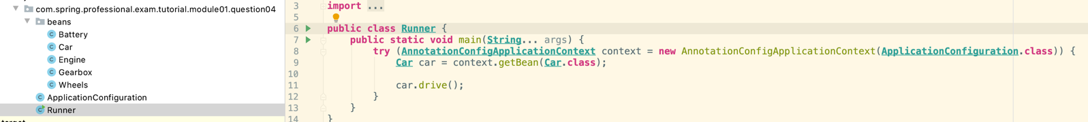

The ApplicationConfiguration class uses @ComponentScan to scan for beans within the package

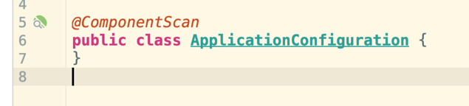

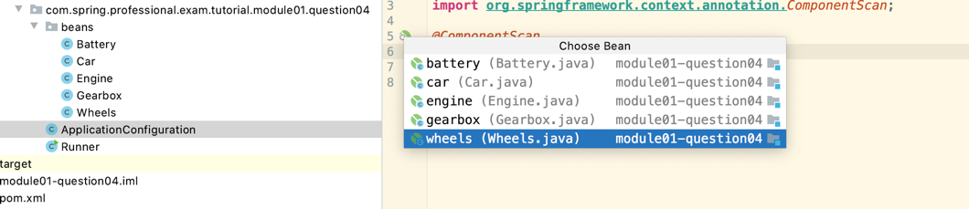

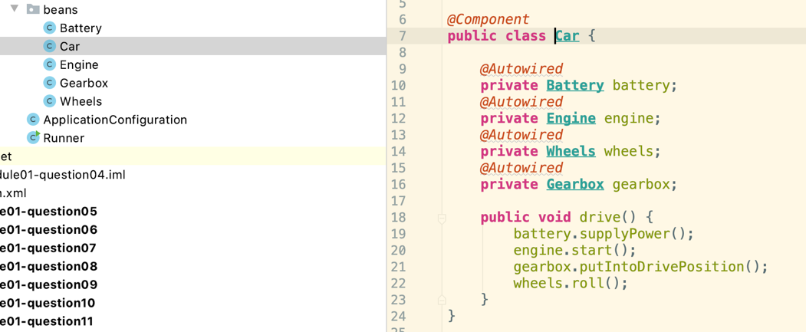

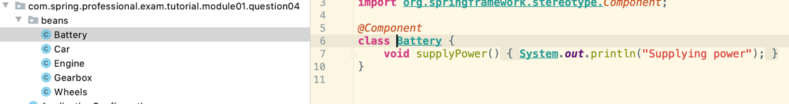

## 1.5 Question 05 - What is the concept of a “container” and what is its lifecycle?

Container is an execution environment which provides additional technical services for your code to use. Usually containers use IoC technique, that allows you to focus on creating business aspect of the code, while technical aspects like communication details (HTTP, REST, SOAP) are provided by execution environment.

Spring provides a container for beans. It manages lifecycle of the beans and also provides additional services through usage of Application Context.

Spring Container Lifecycle:

1. Application is started.
2. Spring container is created.
3. Containers reads configuration.
4. Beans definitions are created from configuration.
5. BeanFactoryPostProcessors are processing bean definitions.
6. Instances of Spring Beans are created.
7. Spring Beans are configured and assembled – resolve property values and inject dependencies.
8. BeanPostProcessors are called – works on beans.
9. Application Runs.
10. Application gets shutdown.
11. Spring Context is closed.
12. Destruction callbacks are invoked.

See what order beans are created and destroyed:

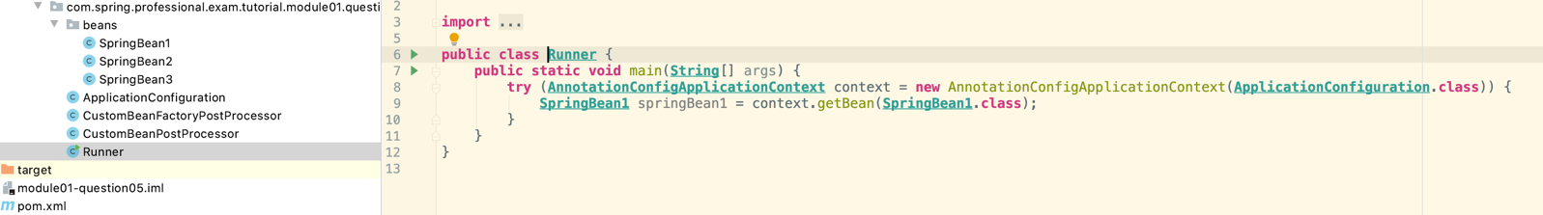

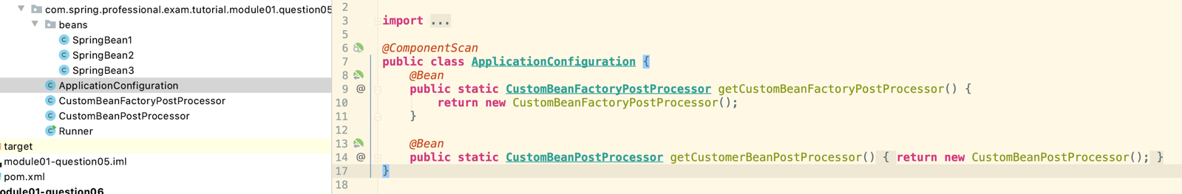

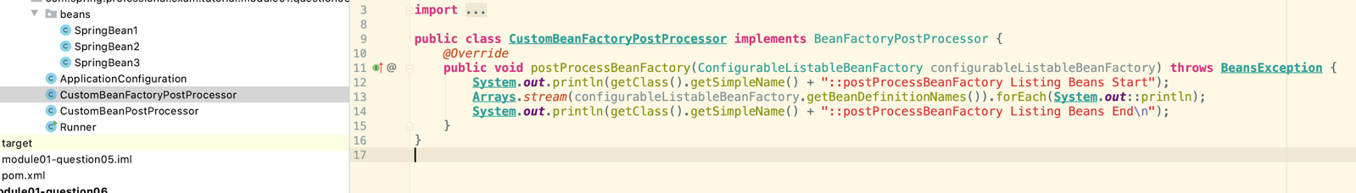

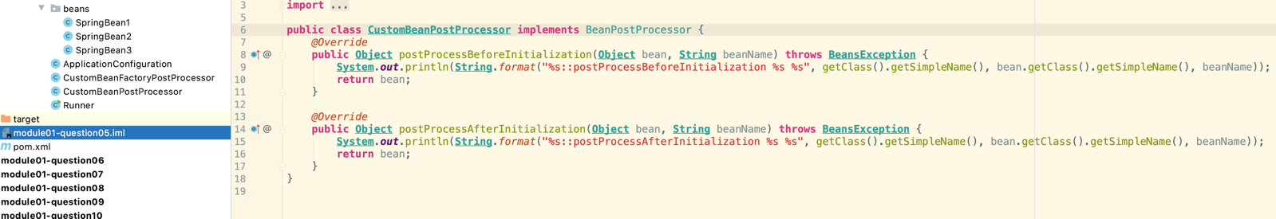

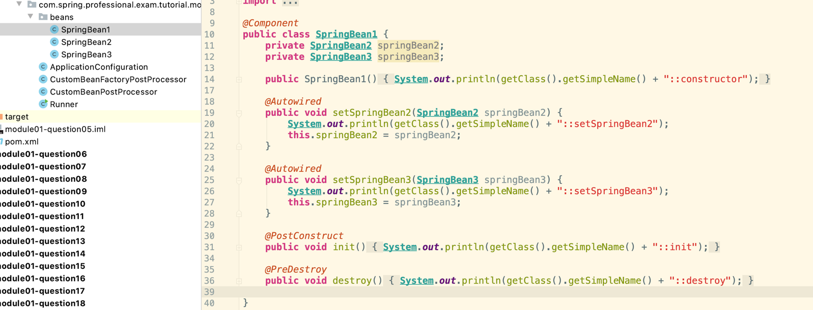

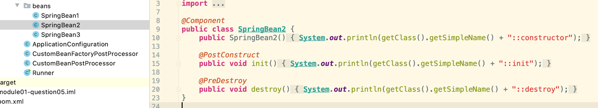

The order:

1. CustomBeanFactoryPostProcessor::postProcessBeanFactory Listing Beans Start
2. org.springframework.context.annotation.internalConfigurationAnnotationProcessor
3. org.springframework.context.annotation.internalAutowiredAnnotationProcessor
4. org.springframework.context.annotation.internalCommonAnnotationProcessor
5. org.springframework.context.event.internalEventListenerProcessor
6. org.springframework.context.event.internalEventListenerFactory
7. applicationConfiguration
8. springBean1
9. springBean2
10. springBean3
11. getCustomBeanFactoryPostProcessor
12. getCustomerBeanPostProcessor
13. CustomBeanFactoryPostProcessor::postProcessBeanFactory Listing Beans End
14. CustomBeanPostProcessor::postProcessBeforeInitialization ApplicationConfiguration applicationConfiguration
15. CustomBeanPostProcessor::postProcessAfterInitialization ApplicationConfiguration applicationConfiguration
16. SpringBean1::constructor
17. SpringBean2::constructor
18. CustomBeanPostProcessor::postProcessBeforeInitialization SpringBean2 springBean2
19. SpringBean2::init @PostConstruct
20. CustomBeanPostProcessor::postProcessAfterInitialization SpringBean2 springBean2
21. SpringBean1::setSpringBean2
22. SpringBean3::constructor
23. CustomBeanPostProcessor::postProcessBeforeInitialization SpringBean3 springBean3
24. SpringBean3::init @PostConstruct
25. CustomBeanPostProcessor::postProcessAfterInitialization SpringBean3 springBean3
26. SpringBean1::setSpringBean3
27. CustomBeanPostProcessor::postProcessBeforeInitialization SpringBean1 springBean1
28. SpringBean1::init @PostConstruct
29. CustomBeanPostProcessor::postProcessAfterInitialization SpringBean1 springBean1
30. SpringBean1::destroy
31. SpringBean3::destroy
32. SpringBean2::destroy

## 1.6 Question 06 - How are you going to create a new instance of an ApplicationContext?

Non-Web Applications:

*  AnnotationConfigApplicationContext – when you want to use the spring bean annotations.

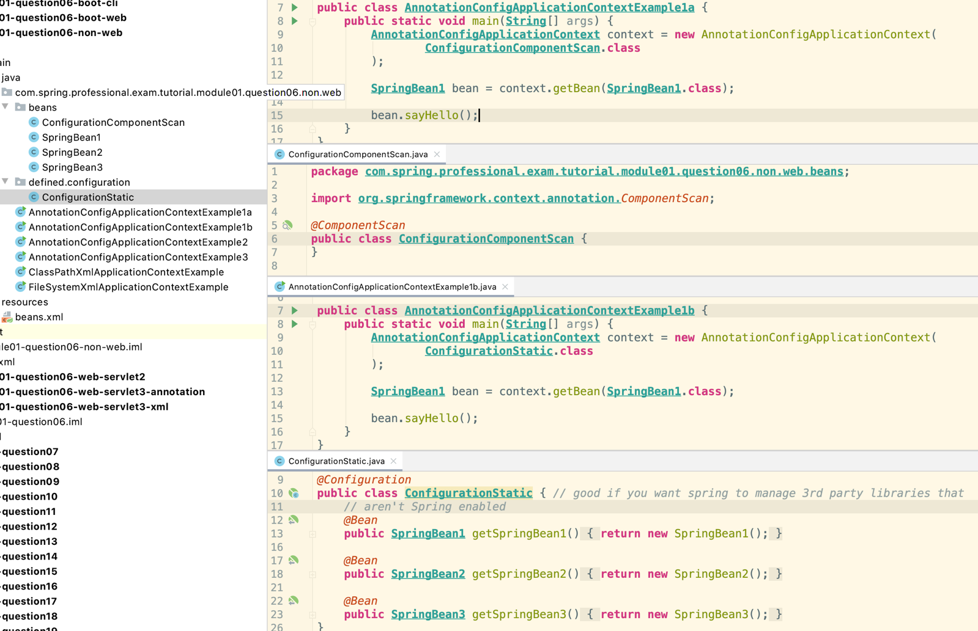

*  ClassPathXmlApplicationContext -xml on the classpath to define all the beans

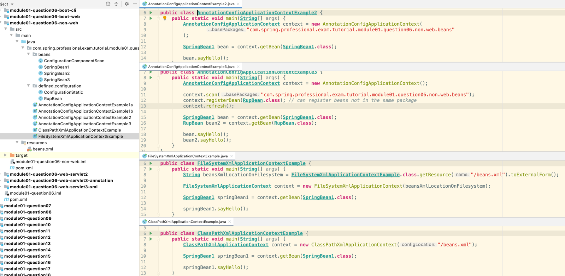

*  FileSystemXmlApplicationContext – xml in filesystem not on classpath.

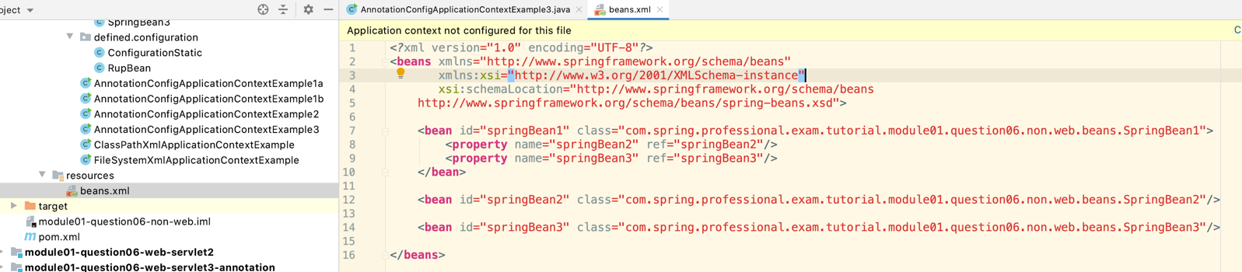

Web Applications:

*  Servlet 2 – web.xml (describes beans), ContextLoaderListener, DispatcherServlet

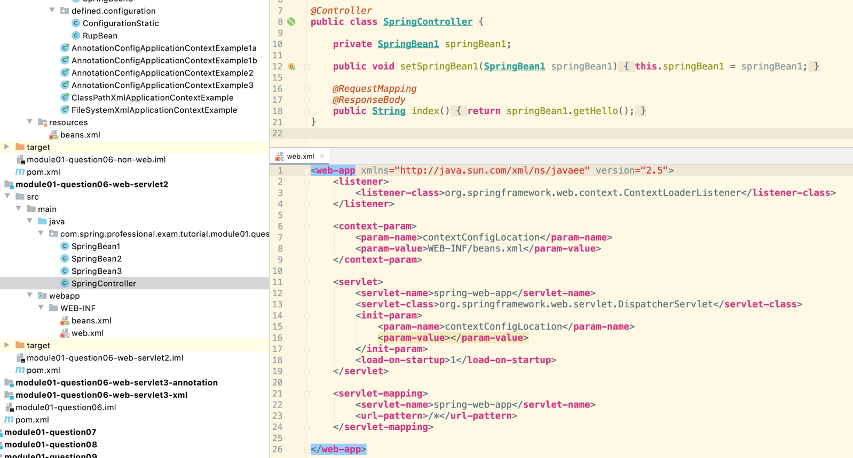

Run as a springWebApplication then go to localhost:8080

*  Servlet 3 – XmlWebApplicationContext

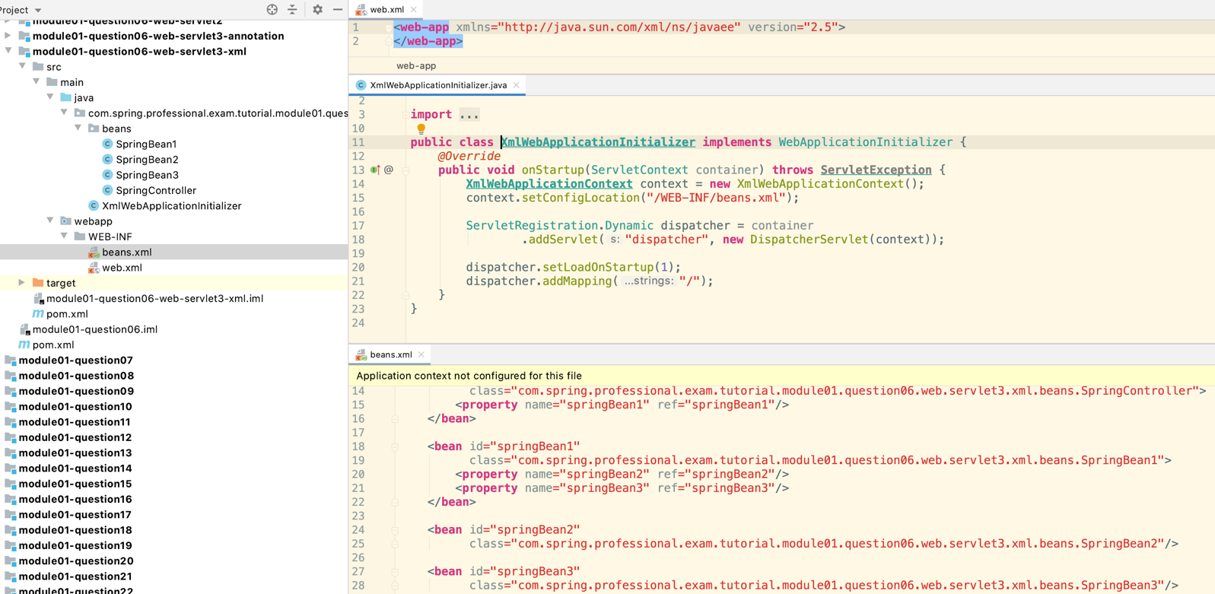

*  Servlet 3 – AnnotationConfigWebApplicationContext

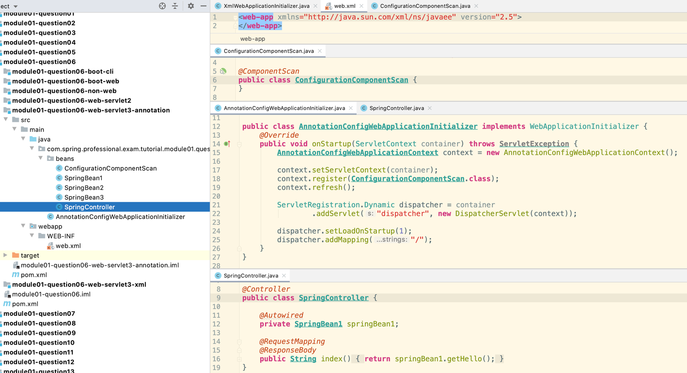

Spring Boot:

*  SpringBootConsoleApplication – CommandLineRunner

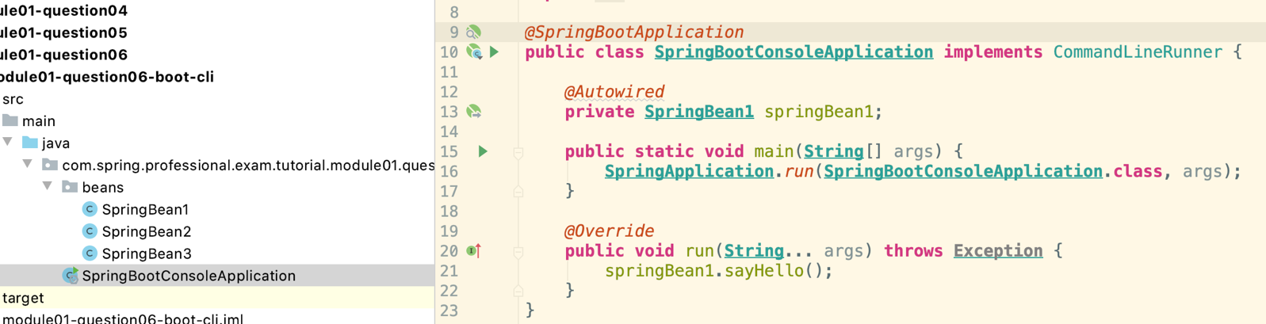

*  SpringBootWebApplication – Embedded Tomcat

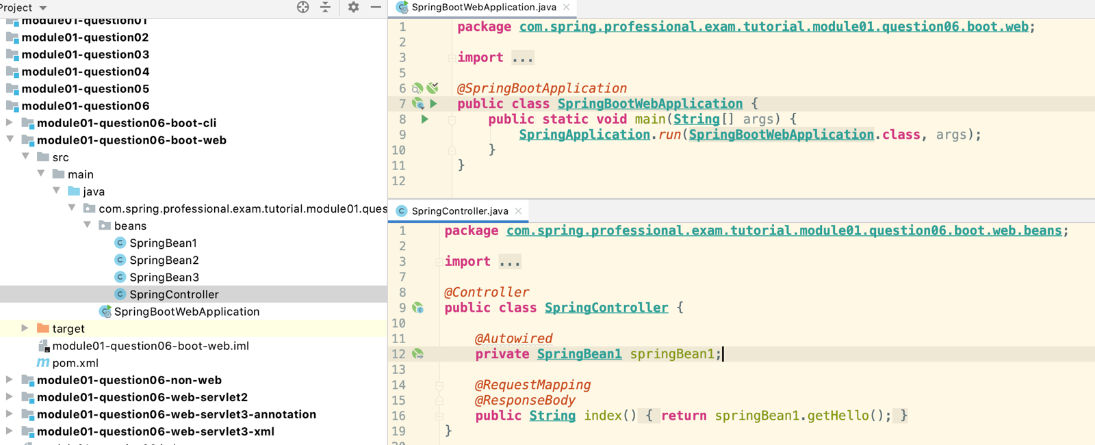

## 1.7 Question 07 - Can you describe the lifecycle of a Spring Bean in an ApplicationContext?

Context is Created:

1. Beans Definitions are created based on Spring Bean Configuration.
2. BeanFactoryPostProcessors are invoked.

Bean is Created:

1. Instance of Bean is Created.
2. Properties and Dependencies are set.
3. BeanPostProcessor::postProcessBeforeInitialization gets called.
4. @PostConstruct method gets called.
5. InitializingBean::afterPropertiesSet method gets called.
6. @Bean(initMethod) method gets called
7. BeanPostProcessor::postProcessAfterInitialization gets called – can customize the bean object.

Bean is Ready to use.

Bean is Destroyed:

1. @PreDestroy method gets called.
2. DisposableBean::destroy method gets called.
3. @Bean(destroyMethod) method gets called.

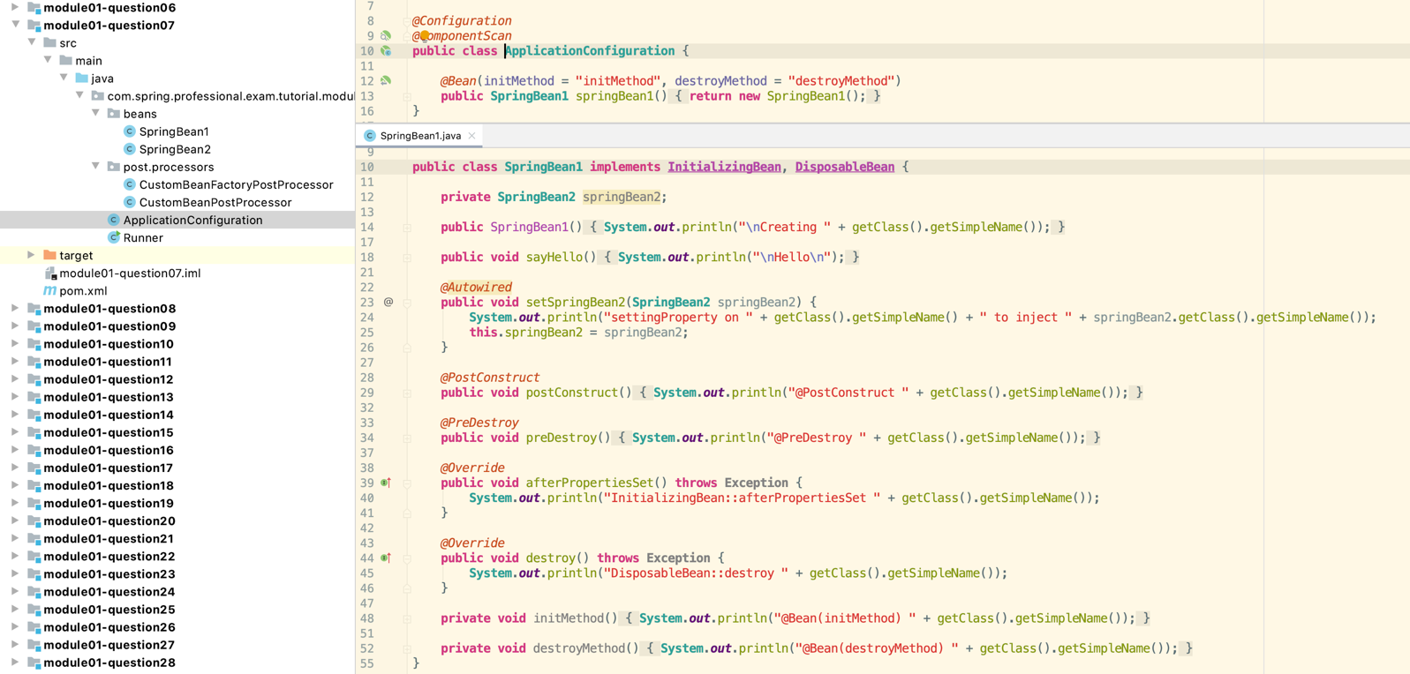

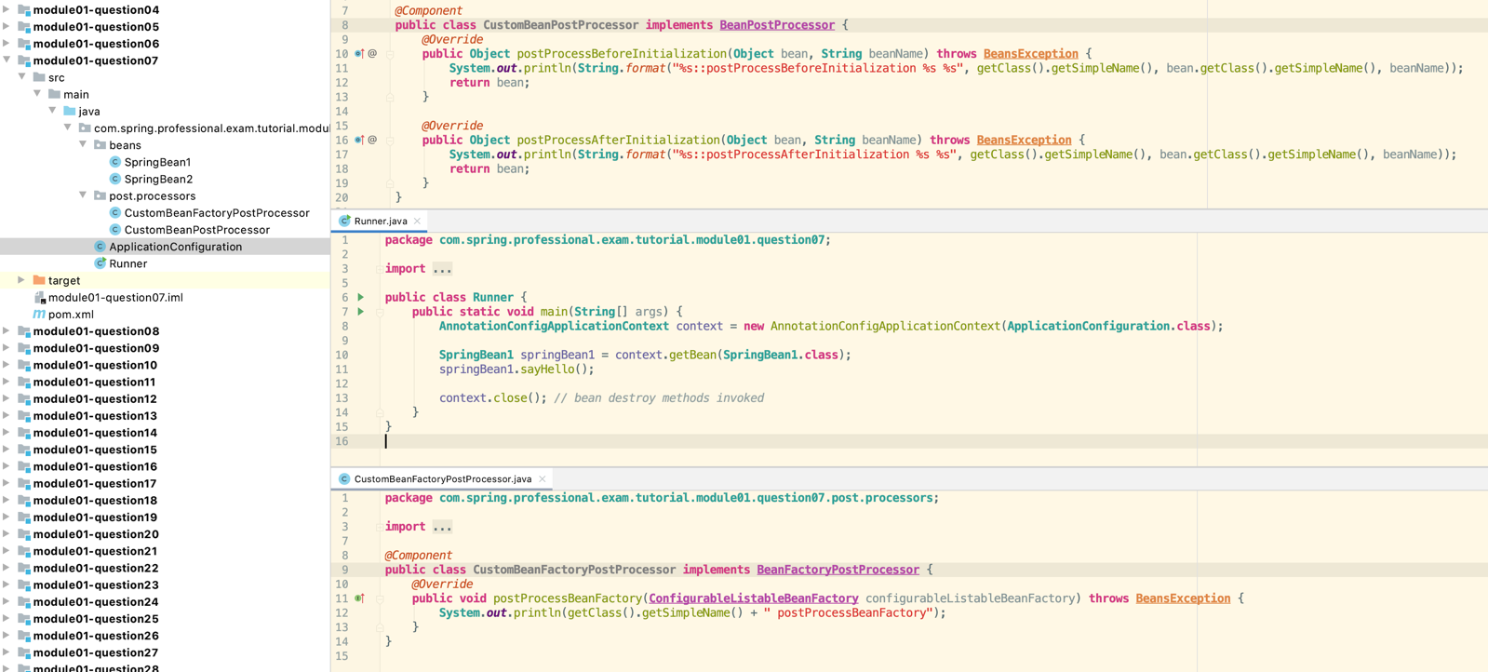

1. CustomBeanFactoryPostProcessor postProcessBeanFactory
2. CustomBeanPostProcessor::postProcessBeforeInitialization ApplicationConfiguration$$EnhancerBySpringCGLIB$$5ed69a07 applicationConfiguration
3. CustomBeanPostProcessor::postProcessAfterInitialization ApplicationConfiguration$$EnhancerBySpringCGLIB$$5ed69a07 applicationConfiguration
4. CustomBeanPostProcessor::postProcessBeforeInitialization SpringBean2 springBean2
5. CustomBeanPostProcessor::postProcessAfterInitialization SpringBean2 springBean2
6. Creating SpringBean1
7. settingProperty on SpringBean1 to inject SpringBean2
8. CustomBeanPostProcessor::postProcessBeforeInitialization SpringBean1 springBean1
9. @PostConstruct SpringBean1
10. InitializingBean::afterPropertiesSet SpringBean1
11. @Bean(initMethod) SpringBean1
12. CustomBeanPostProcessor::postProcessAfterInitialization SpringBean1 springBean1

Hello

1. @PreDestroy SpringBean1
2. DisposableBean::destroy SpringBean1
3. @Bean(destroyMethod) SpringBean1

## 1.8 Question 08 - How are you going to create an ApplicationContext in an integration test?

Need the spring-test dependency added:

<**dependency**>  
 <**groupId**>org.springframework</**groupId**>  
 <**artifactId**>spring-test</**artifactId**>  
 <**scope**>test</**scope**>  
</**dependency**>

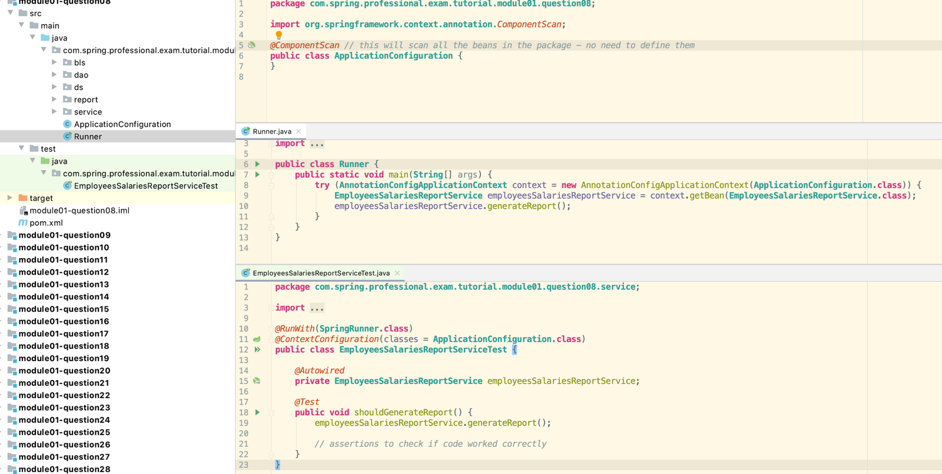

For @ContextConfiguration you can list all the classes you want to test or just use the ApplicationConfiguration.class which finds all the annotated beans.

## 1.9 Question 09 - What is the preferred way to close an application context? Does Spring Boot do this for you?

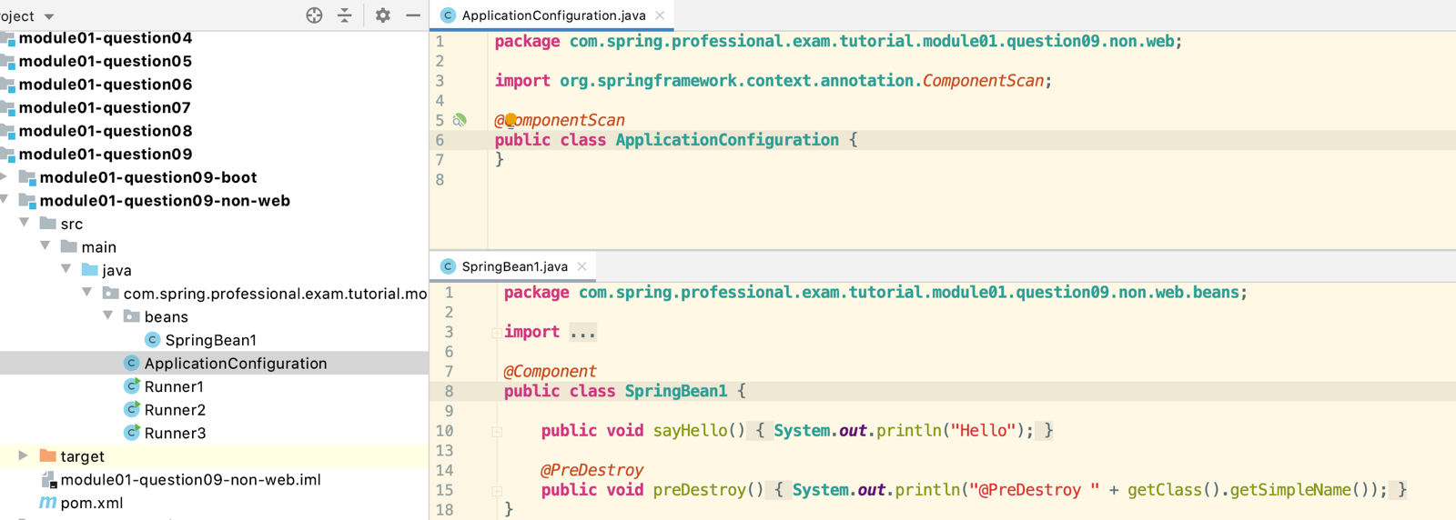

Standalone Non-Web Applications

*  Register Shutdown hook by calling ConfigurableApplicationContext#registerShutdownHook –Recommended way
*  Call ConfigurableApplicationContext#close – not recommended because it will not called if an exception is thrown earlier.
* Or can use try with resources.

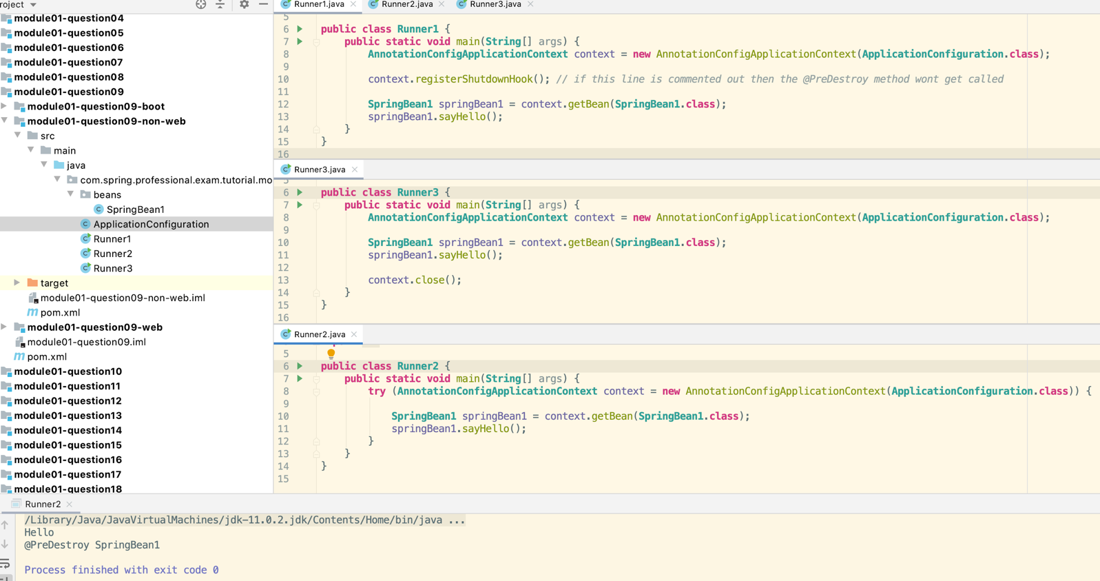

Web Application

*  ContextLoaderListener will automatically close context when web container will stop web application

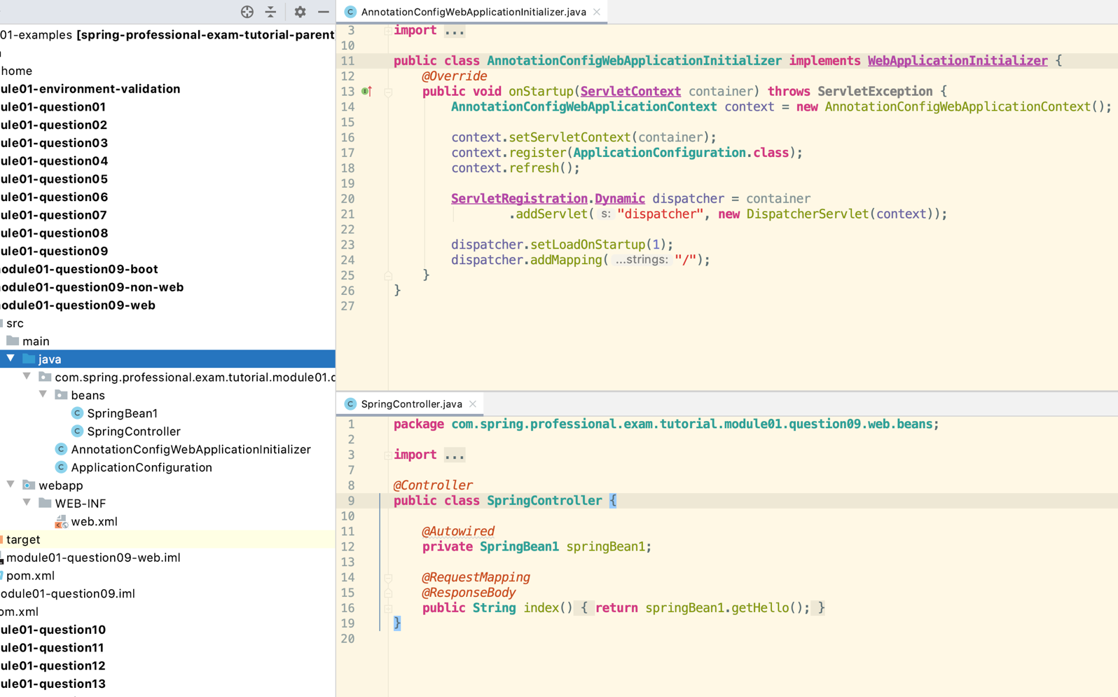

Spring Boot

*  Application Context will be automatically closed – everything is done for you.
*  Shutdown hook will be automatically registered
*  ContextLoaderListener applies to Spring Boot Web Applications as well

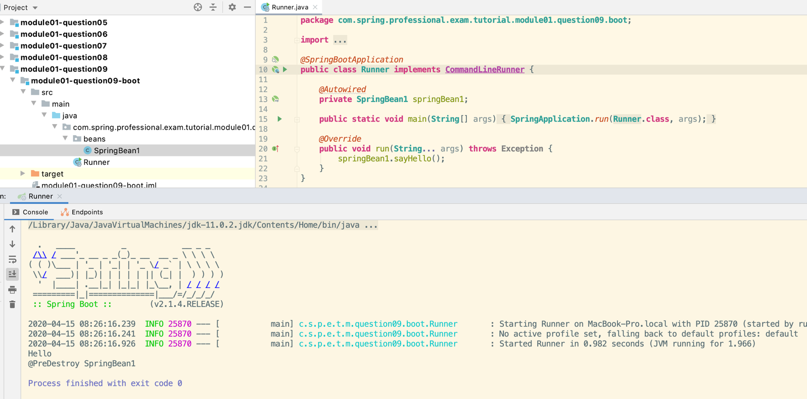

## 1.10 Question 10 - Can you describe: Dependency injection using Java configuration? Dependency injection using annotations (@Component, @Autowired)? Component scanning, Stereotypes and Meta-Annotations? Scopes for Spring beans? What is the default scope?

Beans are named after the method name.

Dependency Injection using Java Configuration

* When using Dependency Injection using Java Configuration you need to explicitly define all your beans and you need to use @Autowire on @Bean method level to inject dependencies.
* *@Configuration***public class ApplicationConfiguration** {  
   *@Bean  
   @Autowired* **public SpringBean1** springBean1(**SpringBean2** springBean2, **SpringBean3** springBean3) {  
   **return new** SpringBean1(springBean2, springBean3);  
   }  
    
   *@Bean* **public SpringBean2** springBean2() {  
   **return new** SpringBean2();  
   }  
    
   *@Bean* **public SpringBean3** springBean3() {  
   **return new** SpringBean3();  
   }  
  }
* **public class SpringBean1** { // note no @Autowired as all the config is done in the ApplicationConfiguration class  
   **private SpringBean2** springBean2;  
   **private SpringBean3** springBean3;  
    
   **public** SpringBean1(**SpringBean2** springBean2, **SpringBean3** springBean3) {  
   **System**.***out***.println(getClass().getSimpleName() + "::constructor");  
   }  
    
   **public void** sayHello() {  
   **System**.***out***.println("Hello");  
   }  
  }

Dependency Injection using Annotations

*  Create classes annotated with @Component annotations
  + *@Component***public class SpringBean2**
*  Define dependencies when required
  + *@Autowired***private SpringBean2** springBean2;  
    *@Autowired***private SpringBean3** springBean3;
*  Create Configuration with Component Scanning Enabled
  + *@ComponentScan***public class ApplicationConfiguration** { // note there are no classes here just uses @ComponentScan  
    }

Now with constructor injection, can also use Setter injection with @Autowired over the setter method

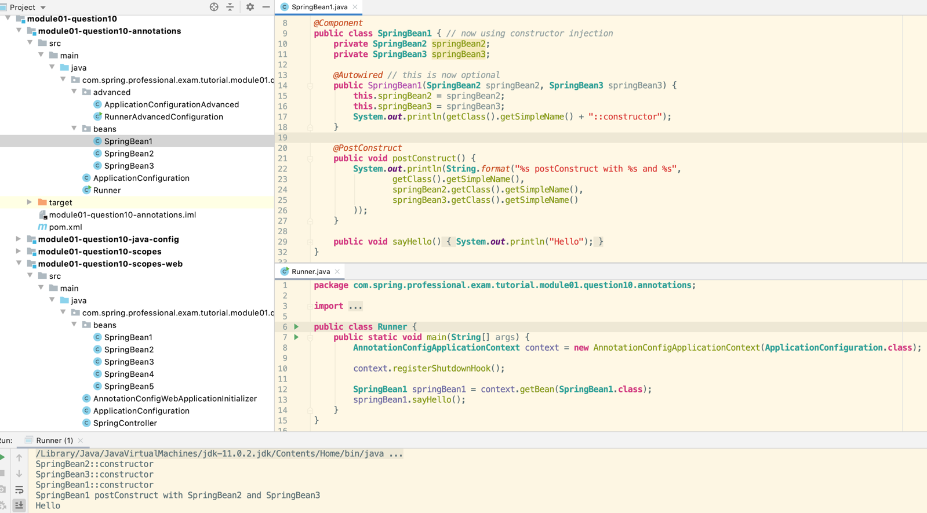

* Component Scanning
  + Process in which Spring is scanning Classpath in search for classes annotated with stereotypes annotations (@Component, @Repository, @Service, @Controller, …) and based on those creates beans definitions.
*  Simple component scanning within Configuration package and all subpackages
  + *@ComponentScan***public class ApplicationConfiguration** { // note there are no classes here just uses @ComponentScan  
    }
*  Advanced Component Scanning Rules
  + *@ComponentScan*(  
     basePackages = "com.spring.professional.exam.tutorial.module01.question10.annotations.beans",  
     *//basePackageClasses = SpringBean1.class, Spring will scan all the packages where this class is located* includeFilters = *@ComponentScan.Filter*(type = **FilterType**.***REGEX***, pattern = ".*Bean.*"),  
     excludeFilters = *@ComponentScan.Filter*(type = **FilterType**.***REGEX***, pattern = ".*Bean1.*")  
    )  
    **public class ApplicationConfigurationAdvanced** {  
    }
* Stereotypes – Definition
  + Stereotypes are annotations applied to classes to describe role which will be performed by this class. Spring discovered classes annotated by stereotypes and creates bean definitions based on those types.
*  Types of stereotypes – you can use @Component for all these classes, the specific annotation just helps describe the use of the class.
  +  Component – generic component in the system, root stereotype, candidate for autoscanning
  +  Service – class will contain business logic
  +  Repository – class is a data repository (used for data access objects, persistence)
  +  Controller – class is a controller, usually a web controller (used with @RequestMapping)
*  Meta-Annotations
  + Meta-annotations are annotations that can be used to create new annotations.
*  Example of Meta-Annotation
  + @RestController annotation is using @Controller and @ResponseBody to define its behaviour
  + *@Target*(**ElementType**.***TYPE***)  
    *@Retention*(**RetentionPolicy**.***RUNTIME***)  
    *@Documented  
    @Controller  
    @ResponseBody***public** @**interface** *RestController* {  
      
     */**  
     * The value may indicate a suggestion for a logical component name,  
     * to be turned into a Spring bean in case of an autodetected component.  
     * @return the suggested component name, if any (or empty String otherwise)  
     * @since 4.0.1  
     */  
     @AliasFor*(annotation = *Controller*.**class**)  
     **String** value() **default** "";  
      
    }
* Scopes of Spring Beans

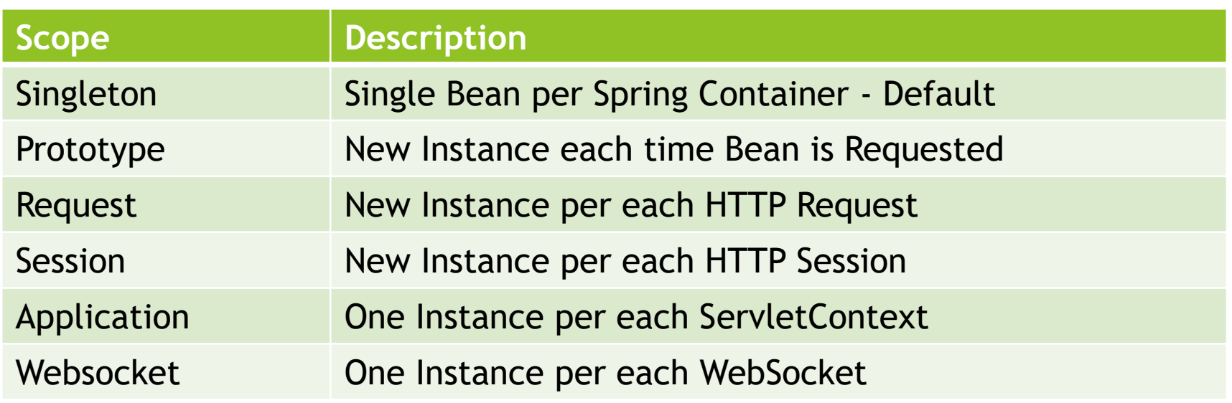

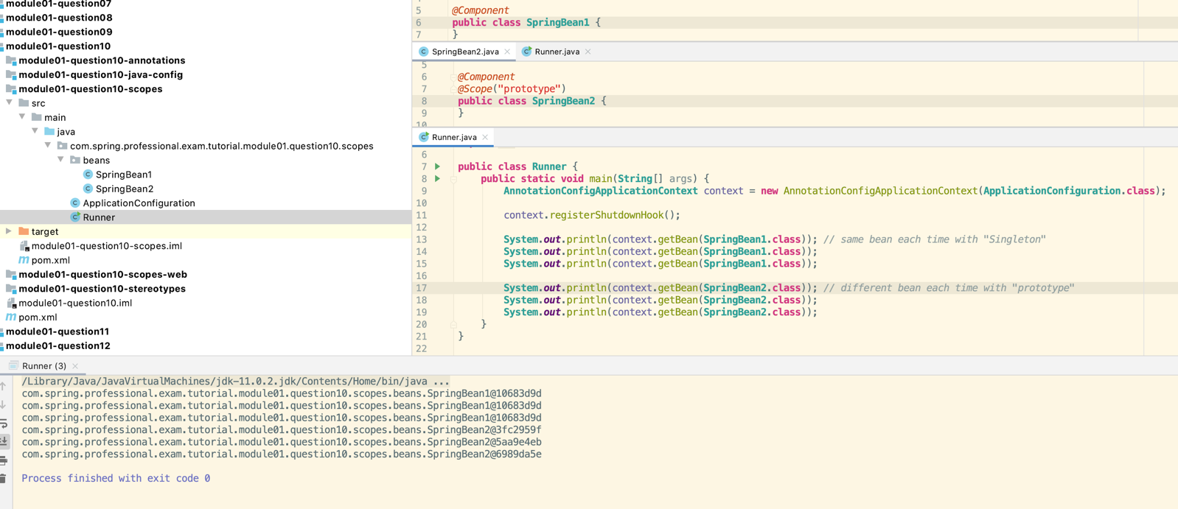

Singleton and Application Beans change when the application is re-started.

Now do the same thing using Springboot

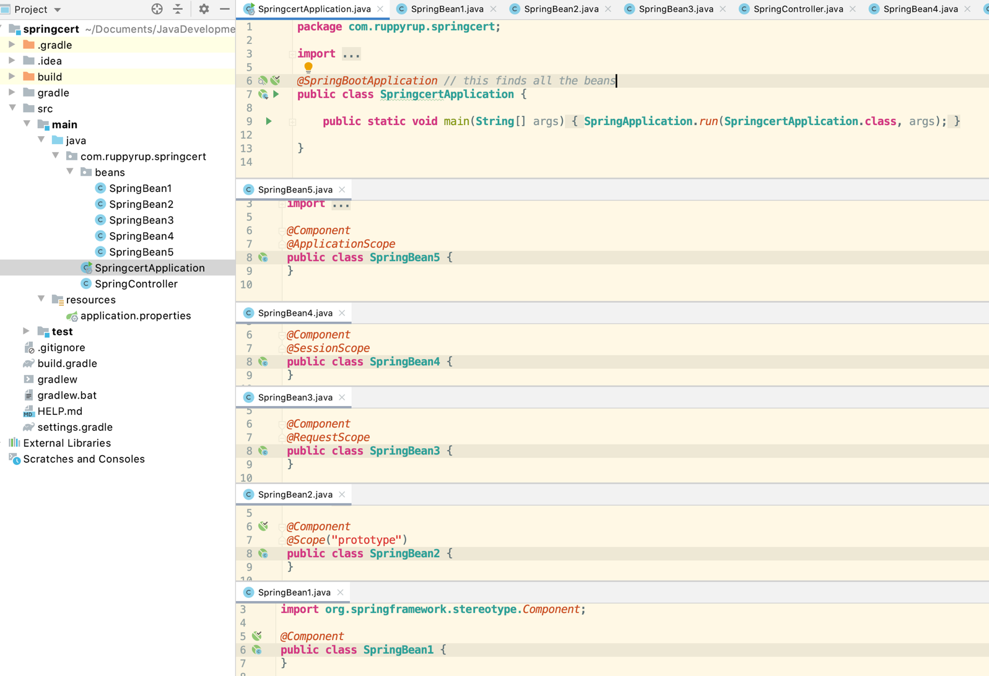

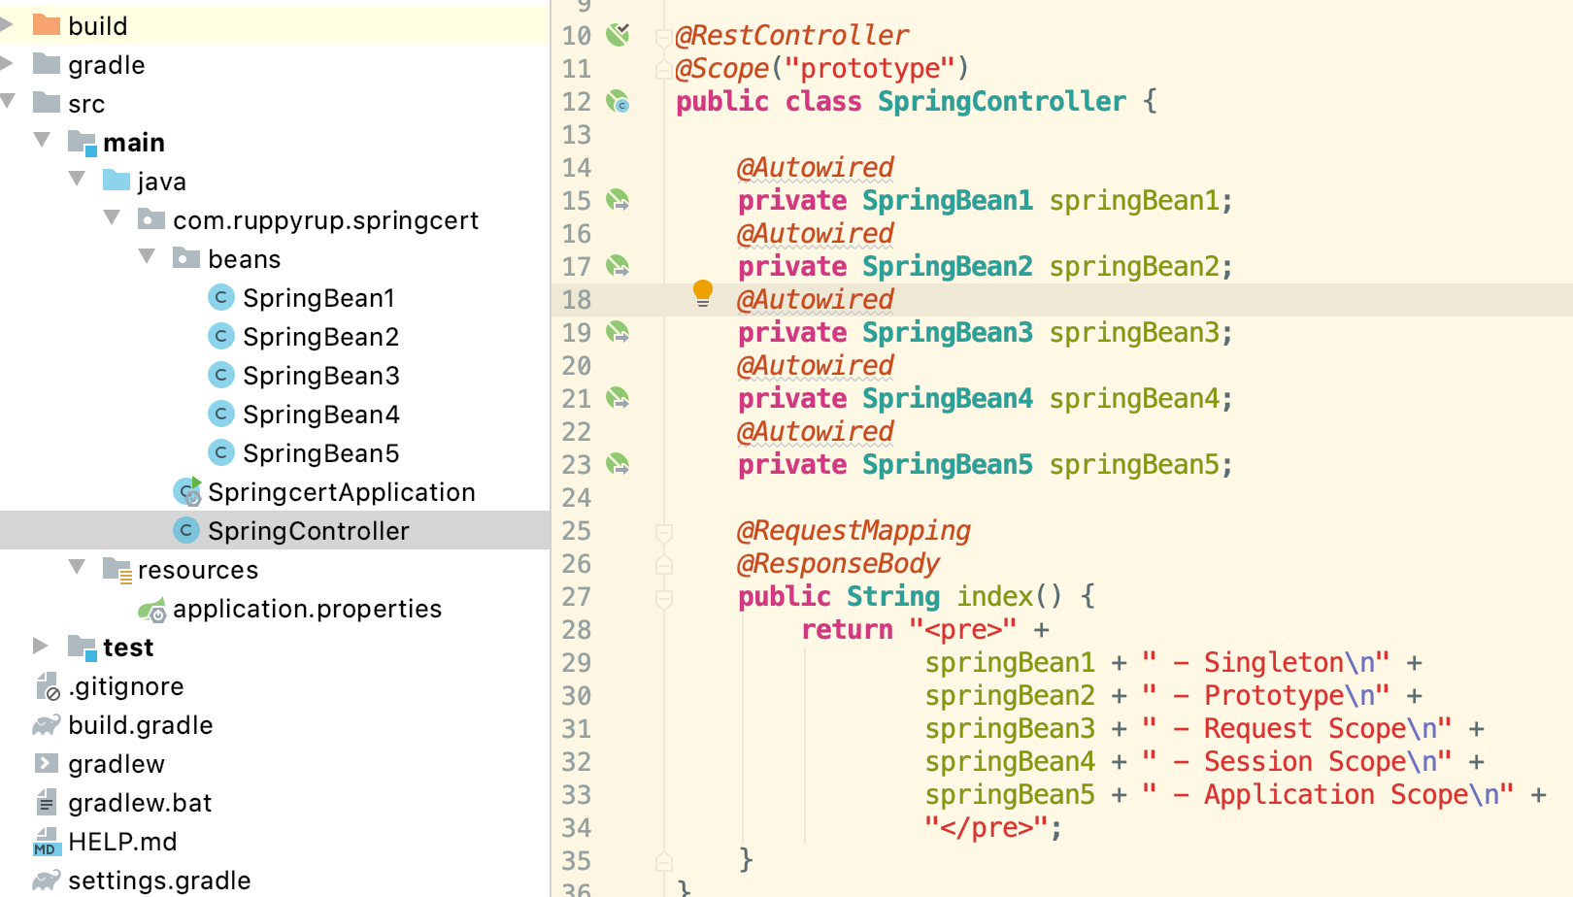

com.ruppyrup.springcert.beans.SpringBean1@28b2eb1 - Singleton

com.ruppyrup.springcert.beans.SpringBean2@e413da3 - Prototype

com.ruppyrup.springcert.beans.SpringBean3@86c21b - Request Scope

com.ruppyrup.springcert.beans.SpringBean4@4b956d3 - Session Scope

com.ruppyrup.springcert.beans.SpringBean5@6047ac0c - Application Scope

After refresh

com.ruppyrup.springcert.beans.SpringBean1@28b2eb1 - Singleton

com.ruppyrup.springcert.beans.SpringBean2@61fea181 - Prototype

com.ruppyrup.springcert.beans.SpringBean3@6f3943ce - Request Scope

com.ruppyrup.springcert.beans.SpringBean4@4b956d3 - Session Scope

com.ruppyrup.springcert.beans.SpringBean5@6047ac0c - Application Scope

New browser

com.ruppyrup.springcert.beans.SpringBean1@28b2eb1 - Singleton

com.ruppyrup.springcert.beans.SpringBean2@688faa6a - Prototype

com.ruppyrup.springcert.beans.SpringBean3@6648490b - Request Scope

com.ruppyrup.springcert.beans.SpringBean4@51c2e508 - Session Scope

com.ruppyrup.springcert.beans.SpringBean5@6047ac0c - Application Scope

Restart the application

com.ruppyrup.springcert.beans.SpringBean1@41d87d28 - Singleton

com.ruppyrup.springcert.beans.SpringBean2@3bb31233 - Prototype

com.ruppyrup.springcert.beans.SpringBean3@15e19ffb - Request Scope

com.ruppyrup.springcert.beans.SpringBean4@646e15b7 - Session Scope

com.ruppyrup.springcert.beans.SpringBean5@b4bc3af - Application Scope

## 1.11 Question 11 - Are beans lazily or eagerly instantiated by default? How do you alter this behaviour?

Lazy and Eager Instance Creation vs Scope Type:

*  Singleton Beans are eagerly instantiated by default
*  Prototype Beans are lazily instantiated by default (instance is created when bean is requested)
  +  …however, if Singleton Bean has dependency on Prototype Bean, then Prototype Bean Instance will be created eagerly to satisfy dependencies for Singleton Bean

Altering Behaviour:

*  You can change default behaviour for all beans by @ComponentScan annotation
  + *@ComponentScan*(lazyInit = **true**) // default is false – no beans created when true
*  Setting lazyInit to true, will make all beans lazy, even Singleton Beans
*  Setting lazyInit to false (default), will create Singleton Beans Eagerly and Prototype Beans Lazily
  + *//@ComponentScan  
    @ComponentScan*(lazyInit = **true**) // no beans will be created  
    *@Configuration  
    //@Lazy // no beans will be created***public class ApplicationConfiguration** {  
    *// @Bean  
    // //@Lazy  
    // public SpringBean7 springBean7() { // need to remove @ComponentScan and can make SpringBean7 lazy  
    // return new SpringBean7();  
    // }  
    //  
    // @Bean  
    // public SpringBean8 springBean8() {  
    // return new SpringBean8();  
    // }*}

◆ You can also change default behaviour by using @Lazy annotation:

*  @Lazy annotation takes one parameter - Whether lazy initialization should occur
*  By default @Lazy is used to mark bean as lazily instantiated
  + *@Component  
    @Lazy***public class SpringBean4** {  
     **public** SpringBean4() {  
     **System**.***out***.println("Creating " + getClass().getSimpleName() + " - Lazy Singleton Bean");  
     }  
    }
*  You can use @Lazy(false) to force Eager Instantiation – use case for @ComponentScan(lazyInit = true) when some beans always needs to be instantiated eagerly
  + *@Component  
    @Lazy*(**false**)  
    **public class SpringBean1** {  
     **public** SpringBean1() {  
     **System**.***out***.println("Creating " + getClass().getSimpleName() + " - Singleton Bean");  
     }  
    }

◆ @Lazy can be applied to:

*  Classed annotated with @Component – makes bean Lazy or as specified by @Lazy parameter
  + *@Component  
    @Lazy***public class SpringBean4** {  
     **public** SpringBean4() {  
     **System**.***out***.println("Creating " + getClass().getSimpleName() + " - Lazy Singleton Bean");  
     }  
    }
*  Classes annotated with @Configuration annotation – make all beans provided by configuration lazy or as specified by
* @Lazy parameter
*  Method annotated with @Bean annotation – makes bean created by method Lazy or as specified by @Lazy parameter

## 1.12 Question 12 - What is a property source? How would you use @PropertySource?

PropertySource is Spring Abstraction on Environment Key-Value pairs, which can come from:

*  JVM Properties
*  System Environmental Variables
*  JNDI Properties
*  Servlet Parameters
*  Properties File Located on Filesystem
*  Properties File Located on Classpath

You read properties with usage of @PropertySource or @PropertySources annotation:

You access properties with usage of @Value annotation:

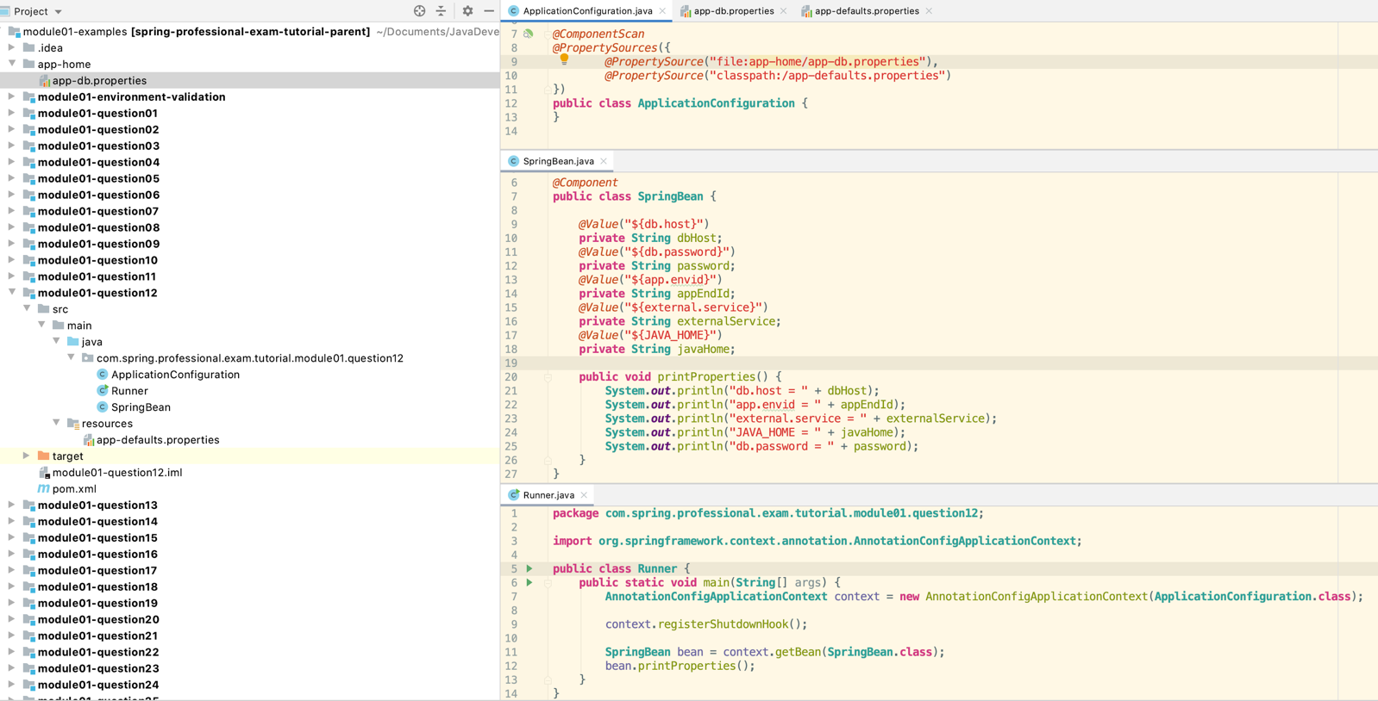

Run with vm options = -Dexternal.service=bob

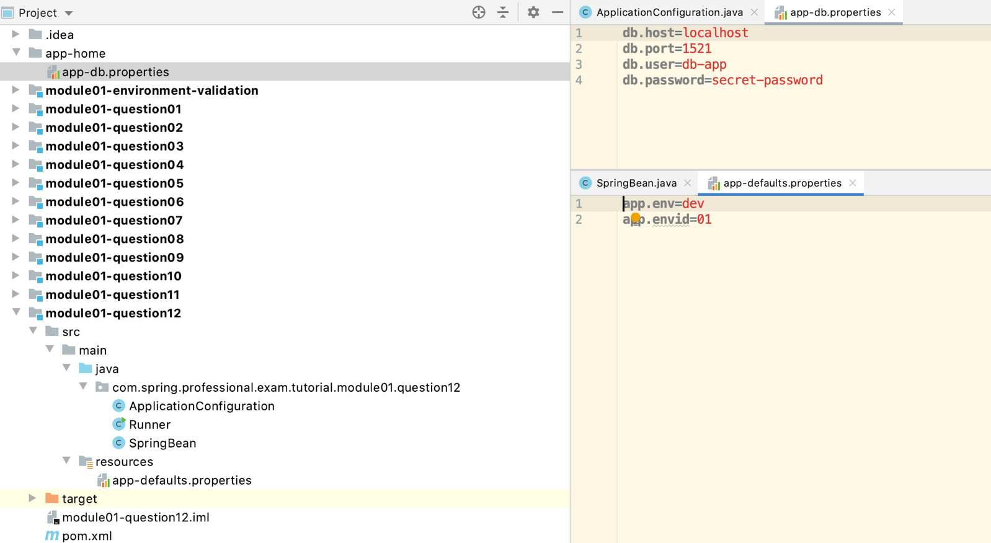

## 1.13 Question 13 - What is a BeanFactoryPostProcessor and what is it used for? When is it invoked? Why would you define a static @Bean method? What is a ProperySourcesPlaceholderConfigurer used for?

BeanFactoryPostProcessor is an interface that contains single method postProcessBeanFactory, implementing it allows you to create logic that will modify Spring Bean Metadata before any Bean is created. BeanFactoryPostProcessor does not create any beans, however it can access and alter Metadata that is used later to create Beans.

BeanFactoryPostProcessor is invoked after Spring will read or discover Bean Definitions, but before any Spring Bean is created.

Because BeanFactoryPostProcessor is also a Spring Bean, but a special kind of Bean that should be invoked before other types of beans get created, Spring needs to have ability to create it before any other beans. This is why BeanFactoryPostProcessors needs to be registered from static method level.

PropertySourcesPlaceholderConfigurer is a BeanFactoryPostProcessor that is used to resolve propertiesplaceholder in Spring Beans on fields annotated with @Value("${property_name}").

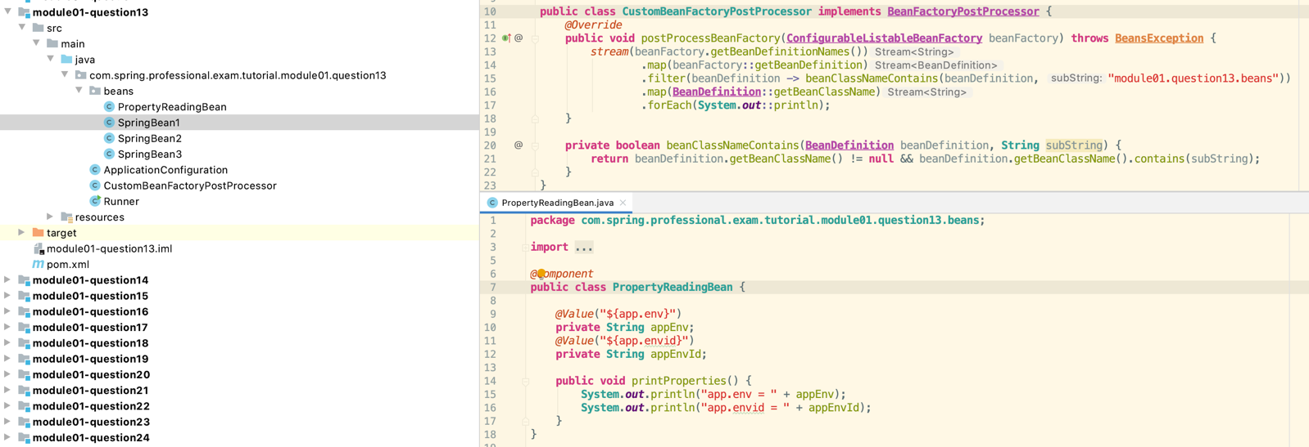

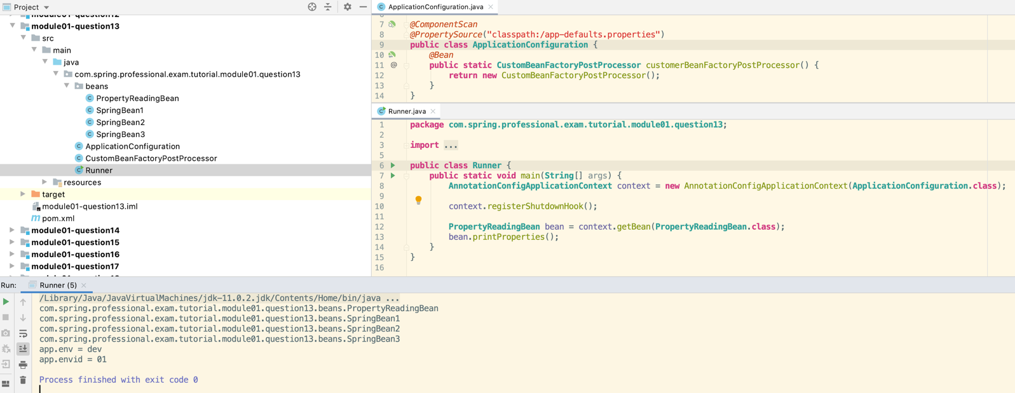

## 1.14 Question 14a - What is a BeanPostProcessor and how is it different to a BeanFactoryPostProcessor? What do they do? When are they called?

BeanPostProcessor is an interface that allows you to create extensions to Spring Framework that will modify Spring Beans objects during initialization. This interface contains two methods:

*  postProcessBeforeInitialization
*  postProcessAfterInitialization

Implementing those methods allows you to modify created and assembled bean objects or even switch object that will represent the bean.

Main difference compared to BeanFactoryPostProcessor is that BeanFactoryPostProcessor works with Bean Definitions while BeanPostProcessor works with Bean Objects.

BeanFactoryPostProcessor and BeanPostProcessor in Spring Container Lifecycle

1. Beans Definitions are created based on Spring Bean Configuration.
2. BeanFactoryPostProcessors are invoked.
3. Instance of Bean is Created.
4. Properties and Dependencies are set.
5. BeanPostProcessor::postProcessBeforeInitialization gets called.
6. @PostConstruct method gets called.
7. InitializingBean::afterPropertiesSet method gets called.
8. @Bean(initMethod) method gets called
9. BeanPostProcessor::postProcessAfterInitialization gets called.

Recommended way to define BeanPostProcessor is through static @Bean method in Application Configuration. This is because BeanPostProcessor should be created early, before other Beans Objects are ready.

*@ComponentScan***public class ApplicationConfiguration** {  
 *@Bean* **public static CustomBeanPostProcessor** customBeanPostProcessor() { created using this method rather than @Component as has to be created first  
 **return new** CustomBeanPostProcessor();  
 }  
  
 *@Bean*(initMethod = "initMethod")  
 **public SpringBean1** springBean1() {  
 **return new** SpringBean1();  
 }  
  
 *@Bean*(destroyMethod = "destroyMethod")  
 **public SpringBean2** springBean2() {  
 **return new** SpringBean2();  
 }  
}

It is also possible to create BeanPostProcessor through regular registration in Application Configuration or through Component Scanning and @Component annotation, however because in that case bean can be created late in processes, recommended way is options provided above.

## 1.14 Question 14b - What is an initialization method and how is it declared on a Spring bean?

Initialization method is a method that you can write for Spring Bean if you need to perform some initialization code that depends on properties and/or dependencies injected into Spring Bean.

You can declare Initialization method in three ways:

*  Create method in Spring Bean annotated with @PostConstruct
*  Implement InitializingBean::afterPropertiesSet
*  Create Bean in Configuration class with @Bean method and use @Bean(initMethod)

**public class SpringBean1 implements InitializingBean** {  
  
 *@PostConstruct* **public void** postConstruct() {  
 **System**.***out***.println(getClass().getSimpleName() + "::postConstruct");  
 }  
  
 *@Override* **public void** afterPropertiesSet() **throws Exception** {  
 **System**.***out***.println(getClass().getSimpleName() + "::afterPropertiesSet");  
 }  
  
 **public void** initMethod() {  
 **System**.***out***.println(getClass().getSimpleName() + "::initMethod");  
 }  
}

## 1.14 Question 14c - What is a destroy method, how is it declared and when is it called?

Destroy method is a method in Spring Bean that you can use to implement any cleanup logic for resources used by the Bean. Method will be called when Spring Bean will be taken out of use, this is usually happening when Spring Context is closed.

You can declare destroy method in following ways:

*  Create method annotated with @PreDestroy annotation
*  Implement DisposableBean::destroy
*  Create Bean in Configuration class with @Bean method and use @Bean(destroyMethod)

**public class SpringBean2 implements DisposableBean** {  
  
 *@PreDestroy* **public void** preDestroy() {  
 **System**.***out***.println(getClass().getSimpleName() + "::preDestroy");  
 }  
  
 *@Override* **public void** destroy() **throws Exception** {  
 **System**.***out***.println(getClass().getSimpleName() + "::destroy");  
 }  
  
 **public void** destroyMethod() {  
 **System**.***out***.println(getClass().getSimpleName() + "::destroyMethod");  
 }  
}

## 1.14 Question 14d - Consider how you enable JSR-250 annotations like @PostConstruct and @PreDestroy?

When using AnnotationConfigApplicationContext support for @PostConstruct and @PreDestroy is added automatically.

Those annotations are handled by CommonAnnotationBeanPostProcessor with is automatically registered by AnnotationConfigApplicationContext.

## 1.14 Question 14e - When/how will they get called? How else can you define an initialization or destruction method for a Spring bean?

Context is Created:

1. Beans Definitions are created based on Spring Bean Configuration.
2. BeanFactoryPostProcessors are invoked.

Bean is Created:

1. Instance of Bean is Created.
2. Properties and Dependencies are set.
3. BeanPostProcessor::postProcessBeforeInitialization gets called.
4. @PostConstruct method gets called.
5. InitializingBean::afterPropertiesSet method gets called.
6. @Bean(initMethod) method gets called
7. BeanPostProcessor::postProcessAfterInitialization gets called.

Bean is Ready to use.

Bean is Destroyed (usually when context is closed):

1. @PreDestroy method gets called.
2. DisposableBean::destroy method gets called.
3. @Bean(destroyMethod) method gets called.

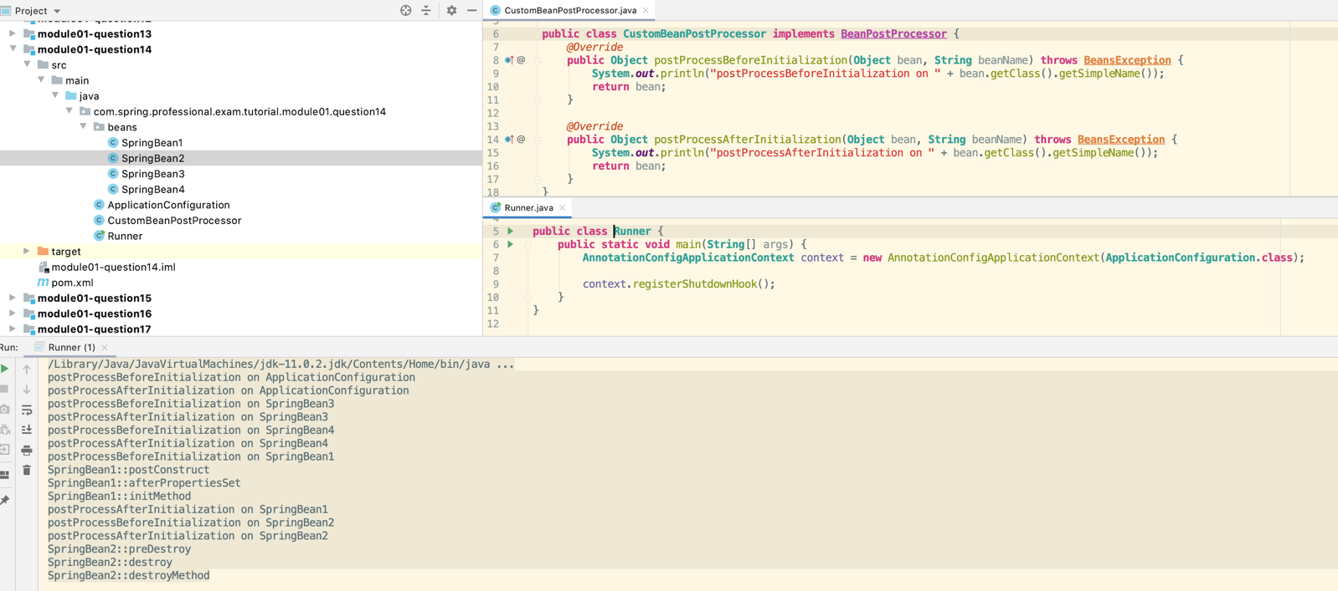

## 1.15 Question 15 – What does component-scanning do?

* Component Scanning
  + Process in which Spring is scanning Classpath in search for classes annotated with stereotypes annotations (@Component, @Repository, @Service, @Controller, …) and based on those creates beans definitions.
* Simple component scanning within Configuration package and all subpackages

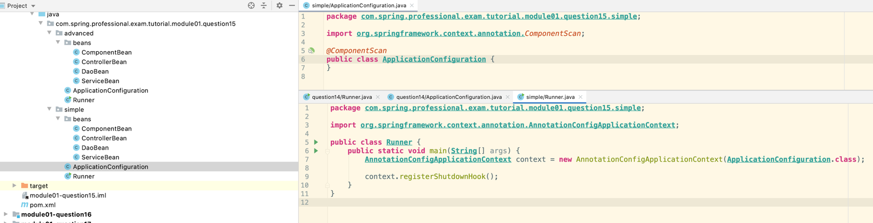

* Advanced Component Scanning Rules

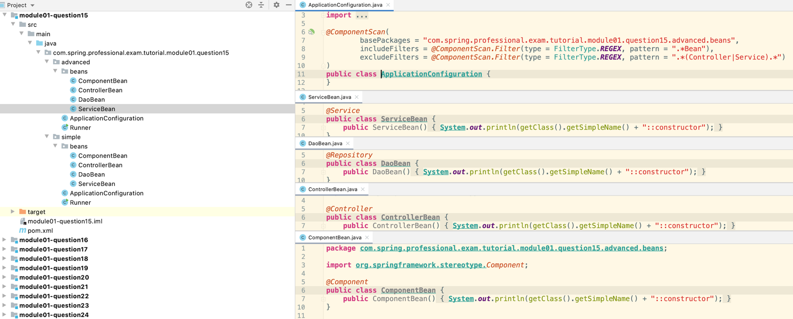

## 1.16 Question 16 – What is the behaviour of the annotation @Autowired with regards to field injection, constructor injection and method injection?

@Autowired is an annotation that is processed by AutowiredAnnotationBeanPostProcessor, which can be put onto class constructor, field, setter method or config method. Using this annotation enables automatic Spring Dependency Resolution that is primary based on types.

@Autowired has a property required which can be used to tell Spring if dependency is required or optional. By default dependency is required. If @Autowired with required dependency is used on top of constructor or method that contains multiple arguments, then all arguments are considered required dependency unless argument is of type Optional, is marked as @Nullable, or is marked as @Autowired(required = false).

@Autowired uses following steps when resolving dependency:

1. Match exactly by type, if only one found, finish.
2. If multiple beans of same type found, check if any contains @Primary annotation, if yes, inject @Primary bean and finish.
3. If no exactly one match exists, check if @Qualifier exists for field, if yes use @Qualifier to find matching bean.
4. If still no exactly one bean found, narrow the search by using bean name.
5. If still no exactly one bean found, throw exception (NoSuchBeanDefinitionException, NoUniqueBeanDefinitionException, …).

@Autowired with field injection is used like this:

*@Service***public class RecordsService01** {  
 *@Autowired* **public DbRecordsReader** recordsReader;  
 *@Autowired* **protected DbRecordsBackup** recordsBackup;  
 *@Autowired* **private DbRecordsProcessor** recordsProcessor;  
 *@Autowired* **DbRecordsWriter** recordsWriter;  
 *@Autowired* **private Optional**<RecordsHash> recordsHash;  
 *@Autowired  
 @Nullable* **private** RecordsUtil recordsUtil;  
 *@Autowired*(required = **false**)  
 **private** RecordsValidator recordsValidator;  
  
 **public** RecordsService01() { *// these are all null as haven't been injected yet - use constructor injection to get them* **System**.***out***.println(  
 getClass().getSimpleName() + " recordsReader = " + recordsReader + "\n" +  
 getClass().getSimpleName() + " recordsBackup = " + recordsBackup + "\n" +  
 getClass().getSimpleName() + " recordsProcessor = " + recordsProcessor + "\n" +  
 getClass().getSimpleName() + " recordsWriter = " + recordsWriter + "\n" +  
 getClass().getSimpleName() + " recordsHash = " + recordsHash + "\n" +  
 getClass().getSimpleName() + " recordsUtil = " + recordsUtil + "\n" +  
 getClass().getSimpleName() + " recordsValidator = " + recordsValidator + "\n"  
 );  
 }  
  
 *@PostConstruct* **public void** init() { *// these have values after construction* **System**.***out***.println(  
 getClass().getSimpleName() + " recordsReader = " + recordsReader + "\n" +  
 getClass().getSimpleName() + " recordsBackup = " + recordsBackup + "\n" +  
 getClass().getSimpleName() + " recordsProcessor = " + recordsProcessor + "\n" +  
 getClass().getSimpleName() + " recordsWriter = " + recordsWriter + "\n" +  
 getClass().getSimpleName() + " recordsHash = " + recordsHash + "\n" +  
 getClass().getSimpleName() + " recordsUtil = " + recordsUtil + "\n" +  
 getClass().getSimpleName() + " recordsValidator = " + recordsValidator + "\n"  
 );  
 }  
}

*  Autowired fields can have any visibility level
*  Injection is happening after Bean is created but before any init method (@PostConstruct, InitializingBean, @Bean(initMethod)) is called
*  By default field is required, however you can use Optional, @Nullable or @Autowired(required = false) to indicate that field is not required.

@Autowired can be used with constructor like this:

*@Service***public class RecordsService02** {  
 **public** RecordsService02(**DbRecordsReader** recordsReader, **DbRecordsBackup** recordsBackup, **DbRecordsProcessor** recordsProcessor, **DbRecordsWriter** recordsWriter) {  
 **System**.***out***.println(  
 getClass().getSimpleName() + " recordsReader = " + recordsReader + "\n" +  
 getClass().getSimpleName() + " recordsBackup = " + recordsBackup + "\n" +  
 getClass().getSimpleName() + " recordsProcessor = " + recordsProcessor + "\n" +  
 getClass().getSimpleName() + " recordsWriter = " + recordsWriter + "\n"  
 );  
 }  
}

Constructor can have any access modifier (public, protected, private, package-private).

If there is only one constructor in class, there is no need to use @Autowired on top of it, Spring will use this default constructor anyway and will inject dependencies into it. If class defines multiple constructor, then you are obligated to use @Autowired to tell Spring which constructor should be used to create Spring Bean. If you will have a class with multiple constructor without any of constructor marked as @Autowired then Spring will throw NoSuchMethodException.

*@Service***public class RecordsService03** {  
  
 *@Autowired* **private** RecordsService03(**DbRecordsReader** recordsReader, **DbRecordsProcessor** recordsProcessor, **Optional**<RecordsUtil> recordsUtil, *@Nullable* RecordsHash recordsHash, *@Autowired*(required = **false**) RecordsValidator recordsValidator) {  
 **System**.***out***.println(  
 getClass().getSimpleName() + " recordsReader = " + recordsReader + "\n" +  
 getClass().getSimpleName() + " recordsProcessor = " + recordsProcessor + "\n" +  
 getClass().getSimpleName() + " recordsUtil = " + recordsUtil + "\n" +  
 getClass().getSimpleName() + " recordsHash = " + recordsHash + "\n" +  
 getClass().getSimpleName() + " recordsValidator = " + recordsValidator + "\n"  
 );  
 }  
  
 *//@Autowired - error if this is uncommented - can only have one autowired constructor* RecordsService03(**DbRecordsReader** recordsReader, **DbRecordsProcessor** recordsProcessor) {  
 **System**.***out***.println(  
 getClass().getSimpleName() + " recordsReader = " + recordsReader + "\n" +  
 getClass().getSimpleName() + " recordsProcessor = " + recordsProcessor + "\n"  
 );  
 }  
}

By default all arguments in constructor are required, however you can use Optional, @Nullable or @Autowired(required = false) to indicate that parameter is not required.

@Autowired can be used with method injection like this:

*@Service***public class RecordsService04** {  
  
 *@Autowired* **public void** setRecordsReader(**DbRecordsReader** recordsReader) {  
 **System**.***out***.println(  
 getClass().getSimpleName() + " setRecordsReader:\n" +  
 "\trecordsReader = " + recordsReader + "\n"  
 );  
 }  
  
 *//@Autowired  
 @Autowired*(required = **false**)  
 *//public void setRecordsReaderAndRecordsValidator(DbRecordsReader recordsReader, Optional<RecordsValidator> recordsValidator) {  
 //public void setRecordsReaderAndRecordsValidator(DbRecordsReader recordsReader, @Nullable RecordsValidator recordsValidator) {  
 //public void setRecordsReaderAndRecordsValidator(DbRecordsReader recordsReader, @Autowired(required = false) RecordsValidator recordsValidator) {* **public void** setRecordsReaderAndRecordsValidator(**DbRecordsReader** recordsReader, RecordsValidator recordsValidator) {  
 **System**.***out***.println(  
 getClass().getSimpleName() + " setRecordsReaderAndRecordsValidator:\n" +  
 "\trecordsReader = " + recordsReader + "\n" +  
 "\trecordsValidator = " + recordsValidator + "\n"  
 );  
 }  
}

@Autowired method can have any visibility level and also can contain multiple parameters. If method contains multiple parameters, then by default it is assumed that in @Autowired method all parameters are required. If Spring will be unable to resolve all dependencies for this method, NoSuchBeanDefinitionException or NoUniqueBeanDefinitionException will be thrown.

When using @Autowired(required = false) with method, it will be invoked only if Spring can resolve all parameters.

If you want Spring to invoke method only with arguments partially resolved, you need to use @Autowired method with parameter marked as Optional, @Nullable or @Autowired(required = false) to indicate that this parameter is not required. If Optional is used and it can’t be resolved it will just add Optional.empty.

If @Autowired is used on top of Collection or Map then Spring will inject all beans matching the type into Collection and key-value pairs as BeanName-Bean into Map. Order of elements depends on usage of @Order, @Priority annotations and implementation of Ordered interface.

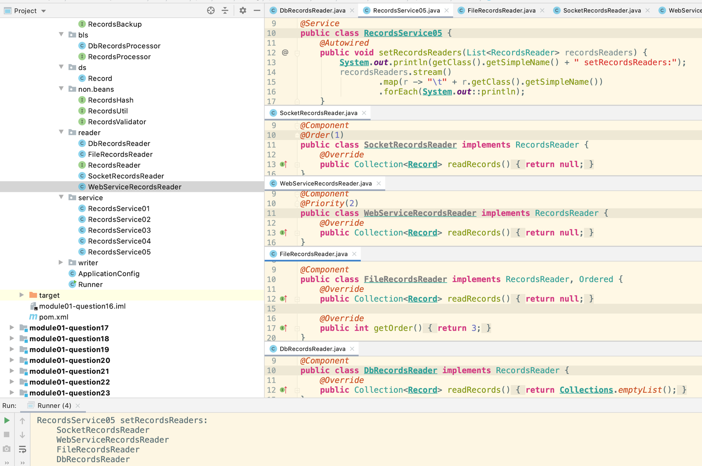

## 1.17 Question 17 – What do you have to do, if you would like to inject something into a private field? How does this impact testing?

Injection of dependency into private field can be done with @Autowired annotation:

*@Autowired***private ReportWriter** reportWriter;

Injection of property into private field can be done with @Value annotation:

*@Value*("${report.global.name}")  
**private String** reportGlobalName;

*@Component***public class ReportService** {  
 *@Autowired* **private ReportWriter** reportWriter;  
  
 *@Value*("${report.global.name}")  
 **private String** reportGlobalName;  
  
 **public void** execute() {  
 **Report** report = **new** Report();  
  
 reportWriter.write(report, reportGlobalName);  
 }  
}

Private Field cannot be accessed from outside of the class, to resolve this when writing Unit Test you can use following solutions:

*  Use SpringRunner with ContextConfiguration and @MockBean
  1. *@RunWith*(**SpringRunner**.**class**)  
     *@ContextConfiguration*(classes = **ApplicationConfig**.**class**)  
     **public class ReportServiceTest01** {  
      *@Autowired* **private ReportService** reportService;  
      *@MockBean* **private ReportWriter** reportWriter;  
       
      *@Test* **public void** shouldPassReportToWriter() {  
      reportService.execute();  
       
      *verify*(reportWriter).write(*any*(**Report**.**class**), *any*());  
      }  
     }
  2. *@RunWith*(**SpringRunner**.**class**) // Modified the test to use @TestPropertySource  
     *@ContextConfiguration*(classes = **ApplicationConfig**.**class**)  
     *@TestPropertySource*(properties = "report.global.name=Test_Report_01")  
     **public class ReportServiceTest01** {  
      *@Autowired* **private ReportService** reportService;  
      *@MockBean* **private ReportWriter** reportWriter;  
       
      *@Test* **public void** shouldPassReportToWriter() {  
      reportService.execute();  
       
      *verify*(reportWriter).write(*any*(**Report**.**class**), *eq*("Test_Report_01"));  
      }  
     }
*  Use ReflectionTestUtils to modify private fields – not good because if “reportWriter” field gets refactored in the code the test wont work
  1. **public class ReportServiceTest03** {  
      **private ReportService** reportService;  
       
      *@Before* **public void** setUp() {  
      reportService = **new** ReportService();  
      }  
       
      *@Test* **public void** shouldPassReportToWriter() {  
      **ReportWriter** reportWriter = **Mockito**.*mock*(**ReportWriter**.**class**);  
      **ReflectionTestUtils**.*setField*(reportService, **ReportService**.**class**, "reportWriter", reportWriter, **ReportWriter**.**class**);  
       
      reportService.execute();  
       
      *verify*(reportWriter).write(*any*(**Report**.**class**), *any*());  
      }  
     }
*  Use MockitoJUnitRunner to inject mocks
  1. *@RunWith*(**MockitoJUnitRunner**.**class**)  
     **public class ReportServiceTest02** {  
      *@InjectMocks* **private ReportService** reportService;  
      *@Mock* **private ReportWriter** reportWriter;  
       
      *@Test* **public void** shouldPassReportToWriter() {  
      reportService.execute();  
       
      *verify*(reportWriter).write(*any*(**Report**.**class**), *any*());  
      }  
     }
*  Use @TestPropertySource to inject test properties into private fields
  1. *@RunWith*(**SpringRunner**.**class**)  
     *@ContextConfiguration*(classes = **ApplicationConfig**.**class**)  
     *@TestPropertySource*(properties = "report.global.name=" + ***REPORT_NAME***)  
     **public class ReportServiceTest04** {  
      **static final String *REPORT_NAME*** = "Mock_Report";  
       
      *@Autowired* **private ReportService** reportService;  
      *@MockBean* **private ReportWriter** reportWriter;  
       
      *@Test* **public void** shouldPassReportToWriter() {  
      reportService.execute();  
       
      *verify*(reportWriter).write(*any*(**Report**.**class**), *eq*(***REPORT_NAME***));  
      }  
     }

## 1.18 Question 18 – How does the @Qualifier annotation complement the use of @Autowired?

@Qualifier annotation gives you additional control on which bean will be injected, when multiple beans of the same type are found. By adding additional information on which bean you want to inject, @Qualifier resolves issues with NoUniqueBeanDefinitionException.

You can use @Qualifier in three ways:

*  At injection point with bean name as value
  + *@Service***public class RecordsService** {  
     *@Autowired  
     @Qualifier*("dbRecordsProcessor")  
     **private RecordsProcessor** recordsProcessor;
  + *@Component // No qualifier annotation spring gives name dbRecordsProcessor***public class DbRecordsProcessor implements RecordsProcessor** {  
     *@Override* **public Collection**<**Record**> processRecords(**Collection**<**Record**> records) {  
     **return Collections**.*emptyList*();  
     }  
    }
  + *@Component // No qualifier annotation spring gives name fileRecordsProcessor***public class FileRecordsProcessor implements RecordsProcessor** {  
     *@Override* **public Collection**<**Record**> processRecords(**Collection**<**Record**> records) {  
     **return null**;  
     }  
    }
*  At injection and bean definition point
  + *@Service***public class RecordsService** {  
     *@Autowired  
     @Qualifier*("file-records-reader")  
     **private RecordsReader** recordsReader;
  + *@Component*("db-records-reader")  
    **public class DbRecordsReader implements RecordsReader** {  
     *@Override* **public Collection**<**Record**> readRecords() {  
     **return Collections**.*emptyList*();  
     }  
    }
  + *@Component*("file-records-reader")  
    **public class FileRecordsReader implements RecordsReader** {  
     *@Override* **public Collection**<**Record**> readRecords() {  
     **return null**;  
     }  
    }
*  Using Qualifier Annotation
  + *@Service***public class RecordsService** {  
     *@Autowired  
     @Qualifier*("db-writer")  
     **private RecordsWriter** recordsWriter;
  + *@Component  
    @Qualifier*("db-writer")  
    **public class DbRecordsWriter implements RecordsWriter** {  
     *@Override* **public void** writeRecords(**Collection**<**Record**> records) {  
      
     }  
    }
* Custom Qualifier Annotation Definition
* *@Service***public class RecordsService** {  
   *@Autowired  
   @RecordsValidatorType*(***FILE***)  
   **private RecordsValidator** recordsValidator;  
  }
* *@Qualifier  
  @Target*({**ElementType**.***FIELD***, **ElementType**.***METHOD***, **ElementType**.***PARAMETER***, **ElementType**.***TYPE***})  
  *@Retention*(**RetentionPolicy**.***RUNTIME***)  
  **public** @**interface** *RecordsValidatorType* {  
    
   **RecordsValidatorMode** value();  
    
   **enum RecordsValidatorMode** {  
   ***DB***,  
   ***FILE*** }  
  }
* *@Component  
  @RecordsValidatorType*(***FILE***)  
  **public class FileRecordsValidator implements RecordsValidator** {  
   *@Override* **public void** validate(**Collection**<**Record**> records) {  
    
   }  
  }
* *@Component  
  @RecordsValidatorType*(***DB***)  
  **public class DbRecordsValidator implements RecordsValidator** {  
   *@Override* **public void** validate(**Collection**<**Record**> records) {  
    
   }  
  }

## 1.19 Question 19 – What is a proxy object and what are the two different types of proxies Spring can create? What are the limitations of these proxies (per type)? What is the power of a proxy object and where are the disadvantages?

Proxy Object is an object that adds additional logic on top of object that is being proxied without having to modify code of proxied object. Proxy object has the same public methods as object that is being proxied and it should be as much as possible indistinguishable from proxied object. When method is invoked on Proxy Object, additional code, usually before and after sections are invoked, also code from proxied object is invoked by Proxy Object.

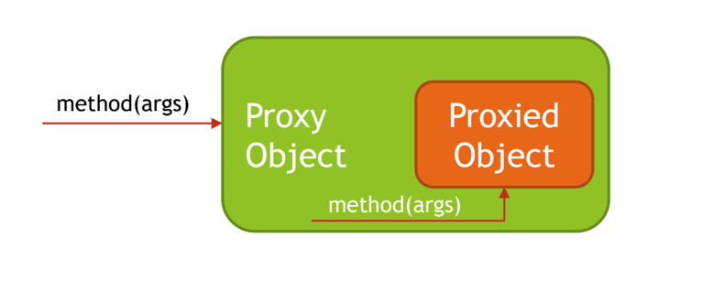

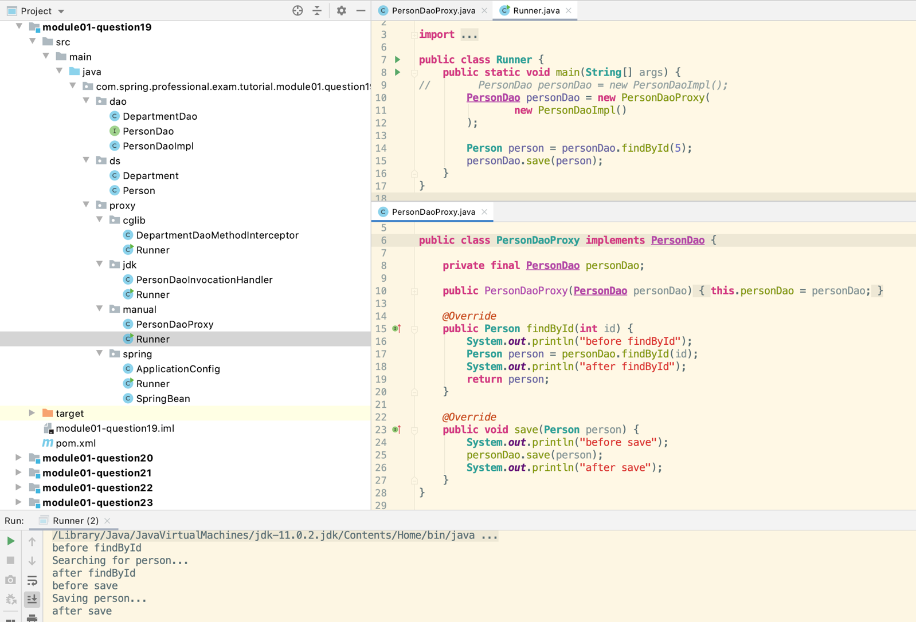

General proxy pattern – bit like decorator

Spring Framework supports two kind of proxies:

*  JDK Dynamic Proxy – used by default if target object implements interface
*  CGLIB Proxy – use when target does not implement any interface

Limitations of JDK Dynamic Proxy:

*  Requires proxy object to implement the interface
*  Only interface methods will be proxied
*  No support for self-invocation
* More code reuse

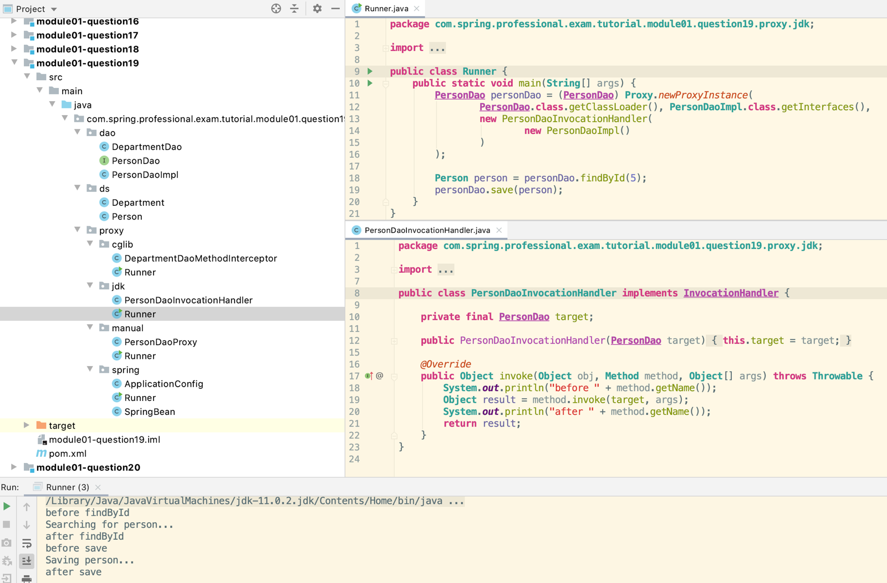

Limitations of CGLIB Proxy:

*  Does not work for final classes
*  Does not work for final methods
*  No support for self-invocation – calling methods on itself

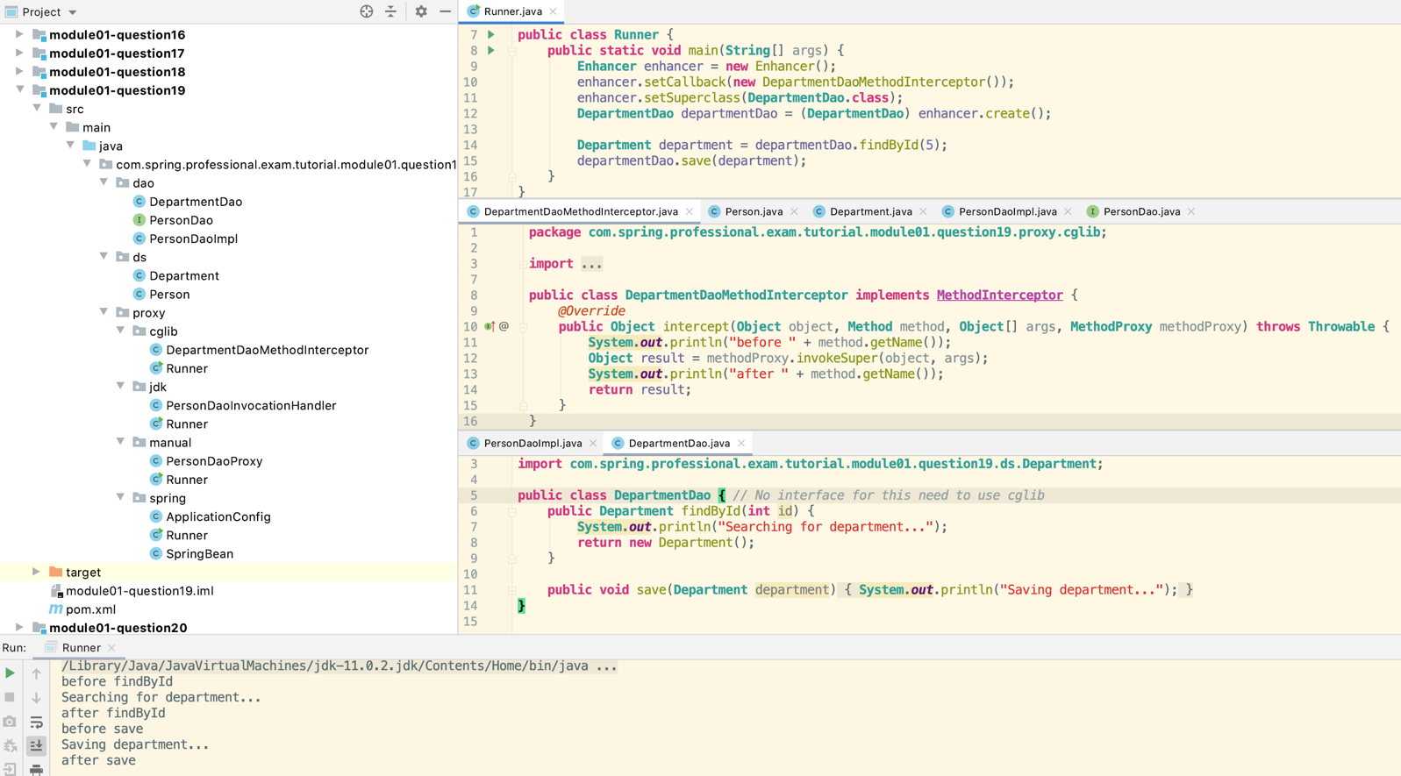

Proxy Advantages:

*  Ability to change behaviour of existing beans without changing original code
*  Separation of concerns (logging, transactions, security, …)

Proxy Disadvantages:

*  May create code hard to debug
*  Needs to use unchecked exception for exceptions not declared in original method
*  May cause performance issues if before/after section in proxy code is using IO (Network, Disk)
*  May cause unexpected equals operator (==) results since Proxy Object and Proxied Object are two different objects

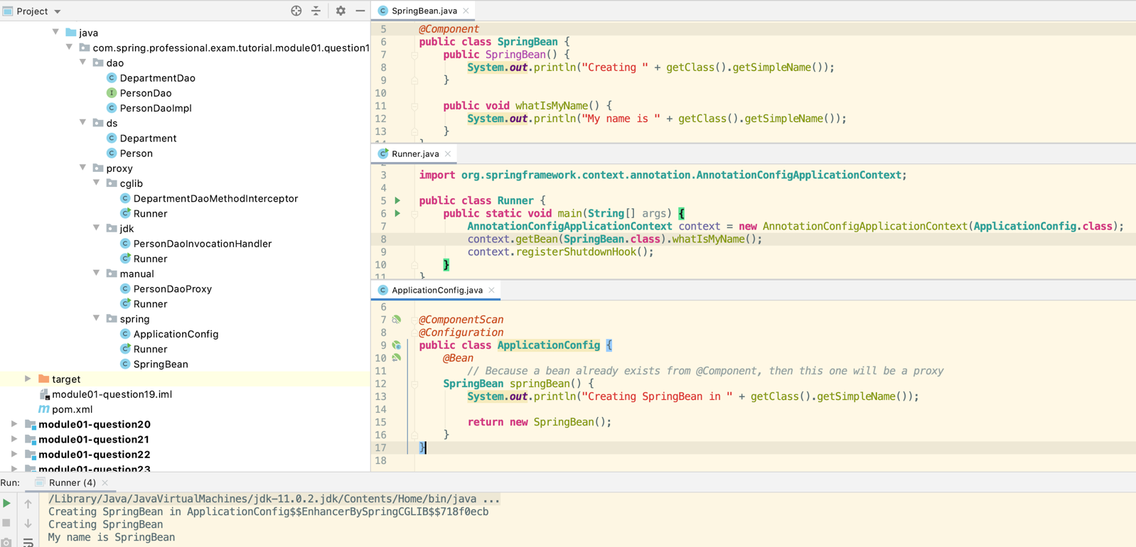

## 1.20 Question 20 – What are the advantages of Java Config? What are the limitations?

Java config:

*@Configuration***public class ApplicationConfig** { // this class can’t be final as cgi proxy is created for this class  
 *@Bean  
 @Autowired* **public SpringBean1** springBean1(**SpringBean2** springBean2, **SpringBean3** springBean3) {  
 **return new** SpringBean1(springBean2, springBean3);  
 }  
  
 *@Bean* **public SpringBean2** springBean2() {  
 **return new** SpringBean2();  
 }  
  
 *@Bean  
 @Autowired* **public SpringBean3** springBean3(**MessageDigest** messageDigest) {  
 **return new** SpringBean3(messageDigest);  
 }  
  
 *@Bean // can integrate with external libraries and create them into beans by creating the method below* **public MessageDigest** messageDigest() {  
 **return DigestUtils**.*getSha384Digest*();  
 }  
}

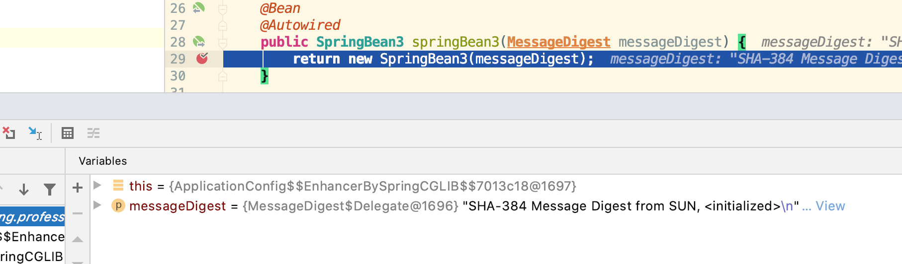

Spring uses cg proxy to guard the behaviour that the spring beans can be invoked only once.

Advantages of Java Config over XML Config:

*  Compile-Time Feedback due to Type-checking
*  Refactoring Tools for Java without special support/plugins work out of the box with Java Config (special support needed for XML Config)
* *<?*xml version="1.0" encoding="UTF-8"*?>*<**beans** xmlns="http://www.springframework.org/schema/beans"  
   xmlns:xsi="http://www.w3.org/2001/XMLSchema-instance"  
   xsi:schemaLocation="http://www.springframework.org/schema/beans  
   http://www.springframework.org/schema/beans/spring-beans.xsd">  
    
   <**bean** id="springBean1"  
   class="com.spring.professional.exam.tutorial.module01.question20.xml.context.beans.SpringBean1">  
   <**constructor-arg** ref="springBean2"/>  
   <**constructor-arg** ref="springBean3"/>  
   </**bean**>  
    
   <**bean** id="springBean2"  
   class="com.spring.professional.exam.tutorial.module01.question20.xml.context.beans.SpringBean2"/>  
    
   <**bean** id="springBean3"  
   class="com.spring.professional.exam.tutorial.module01.question20.xml.context.beans.SpringBean3"/>  
    
  </**beans**>

Advantages of Java Config over Annotation Based Config:

*  Separation of concerns – beans configuration is separated from beans implementation
*  Technology agnostic – beans may not depend on concrete IoC/DI implementation – makes it easier to switch technology
*  Ability to integrate Spring with external libraries
*  More centralized location of bean list

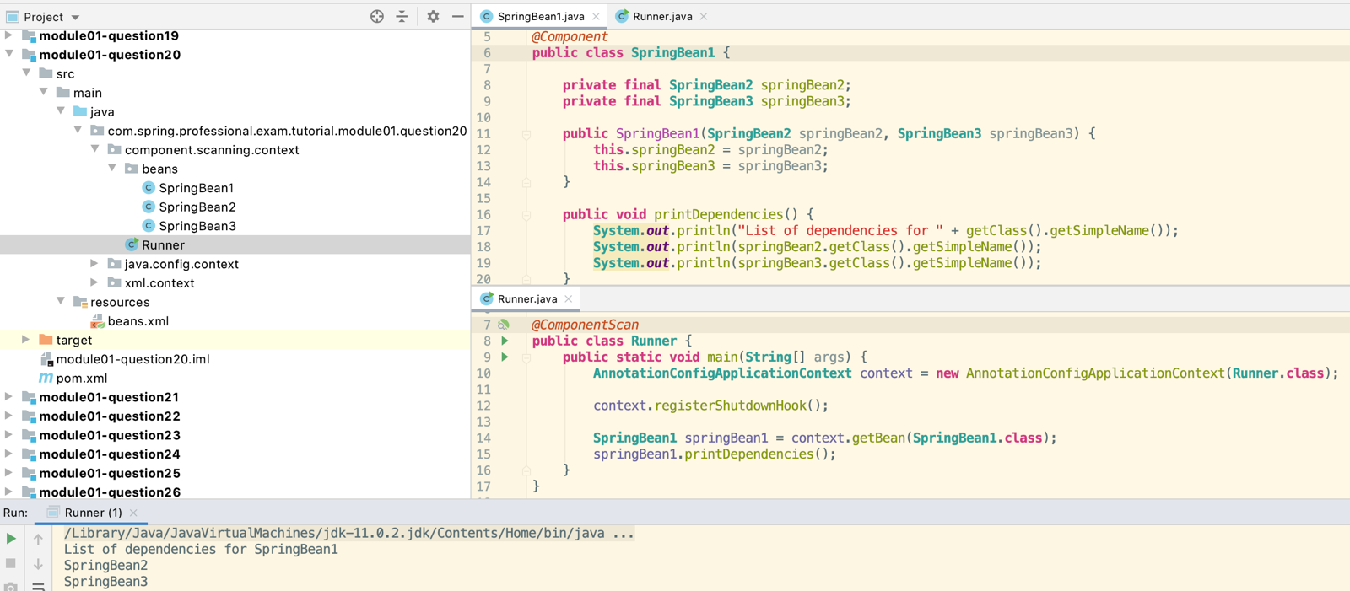

Limitations of Java Config:

*  Configuration class cannot be final
*  Configuration class methods cannot be final
*  All Beans have to be listed, for big applications, it might be a challenge compared to Component Scanning

## 1.21 Question 21 – What does the @Bean annotation do?

@Bean annotation is used in @Configuration class to inform Spring that instance of class returned by method annotated with @Bean will return bean that will be managed by Spring.

@Bean also allows you to:

*  Specify init method – will be called after instance is created and assembled
*  Specify destroy method – will be called when bean is discarded (usually when context is getting closed)
*  Specify name for the bean – by default bean has name autogenerated based on method name, however this can be overridden
*  Specify alias/aliases for the bean
*  Specify if Bean should be used as candidate for injection into other beans – default true
*  Configure Autowiring mode – by name or type (Deprecated since Spring 5.1)

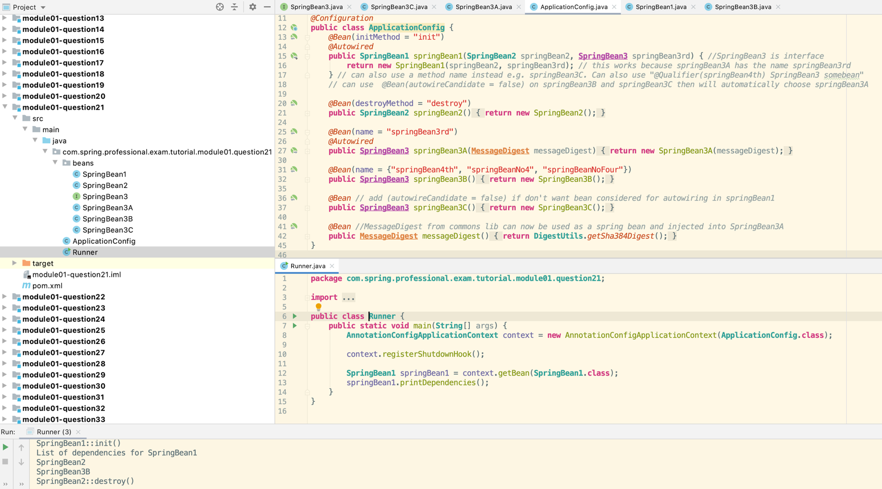

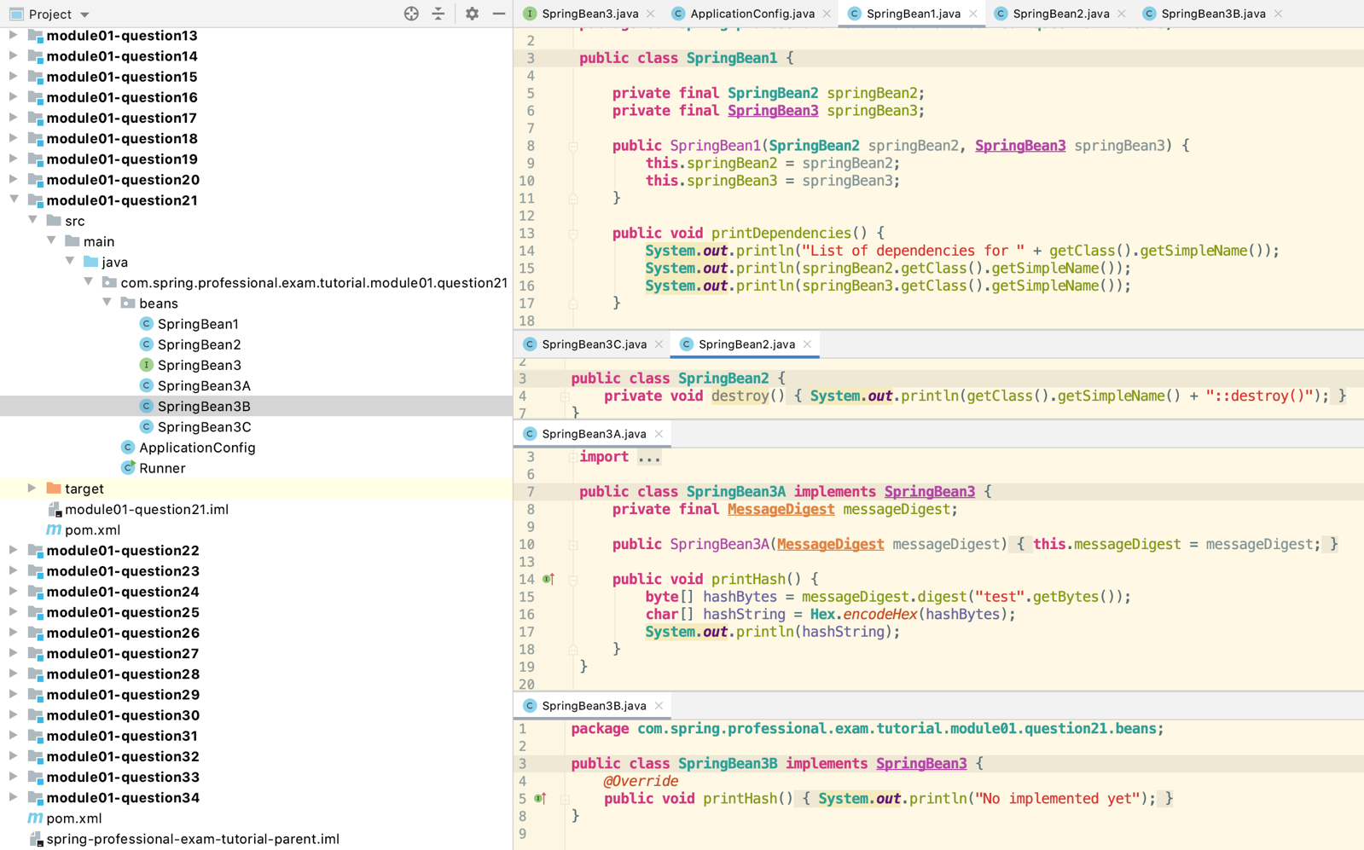

## 1.22 Question 22 – What is the default bean id if you only use @Bean? How can you override this?

When using @Bean without specifying name or alias, default bean id will be created based on name of the method which was annotated with @Bean annotation.

You can override this behaviour by specifying name or aliases for the bean.

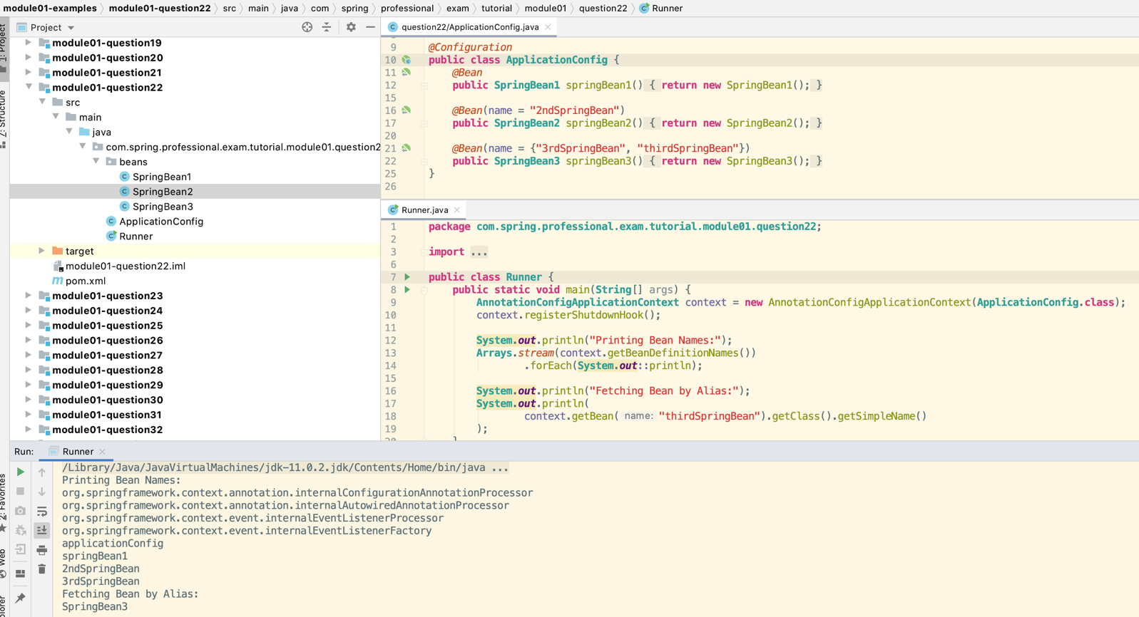

## 1.23 Question 23 – Why are you not allowed to annotate a final class with @Configuration? How do @Configuration annotated classes support singleton beans? Why can’t @Bean methods be final either?

Class annotated with @Configuration cannot be final because Spring will use CGLIB to create a proxy for @Configuration class. CGLIB creates subclass for each class that is supposed to be proxied, however since final class cannot have subclass CGLIB will fail. This is also a reason why methods cannot be final, Spring needs to override methods from parent class for proxy to work correctly, however final method cannot be overridden, having such a method will make CGLIB fail.

If @Configuration class will be final or will have final method, Spring will throw BeanDefinitionParsingException.

Spring supports Singleton beans in @Configuration class by creating CGLIB proxy that intercepts calls to the method. Before method is executed from the proxied class, proxy intercept a call and checks if instance of the bean already exists, if instance of the bean exists, then call to method is not allowed and already existing instance is returned, if instance does not exist, then call is allowed, bean is created and instance is returned and saved for future reuse. To make method call interception CGLIB proxy needs to create subclass and also needs to override methods.

Easiest way to observe that calls to original @Configuration class are proxied is with usage of debugger or by printing stacktrace. When looking at stacktrace you will notice that class which serves beans is not original class written by you but it is different class, which name contains $$EnhancerBySpringCGLIB.

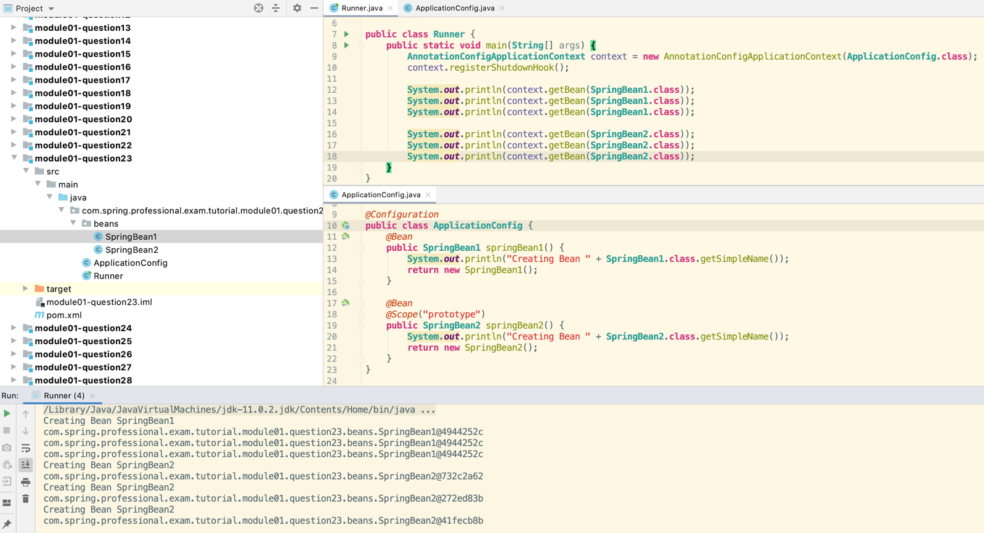

## 1.24 Question 24 – How do you configure profiles? What are possible use cases where they might be useful?

Spring Profiles are configured by:

*  Specifying which beans are part of which profile
*  Specifying which profiles are active

You can specify beans being part of profile in following ways:

*  Use @Profile annotation at @Component class level – bean will be part of profile/profiles specified in annotation

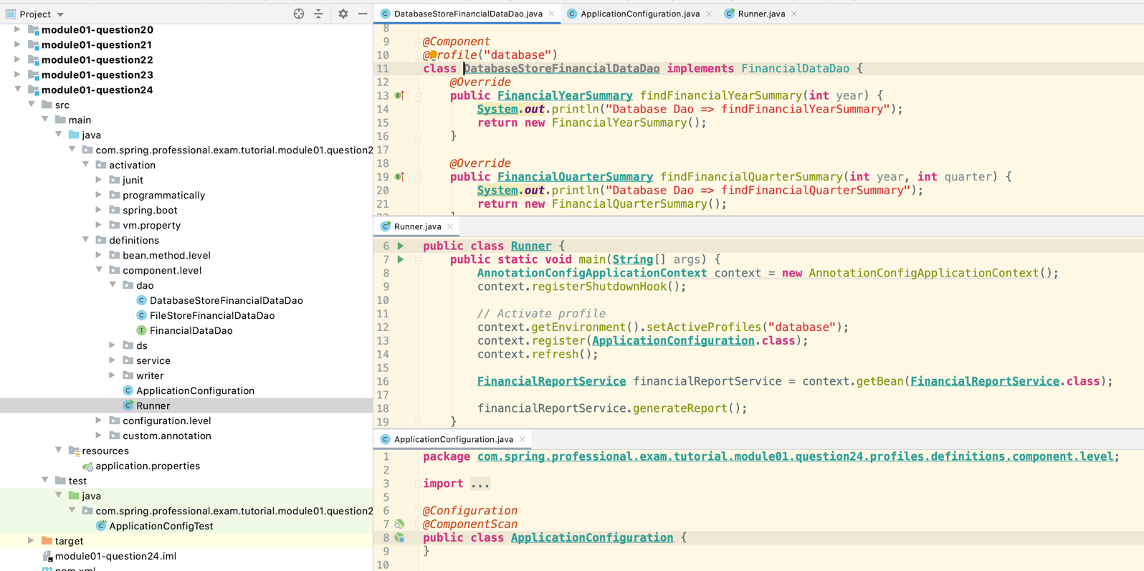

*  Use @Profile annotation at @Configuration class level – all beans from this configuration will be part of profile/profiles specified in annotation

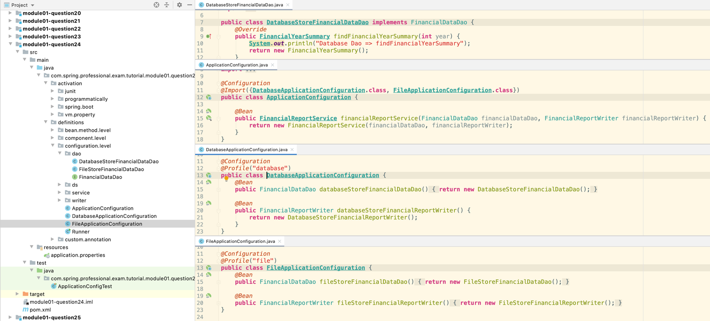

*  Use @Profile annotation at @Bean method of @Configuration class – instance of bean returned by this method will be part of profile/profiles specified in annotation

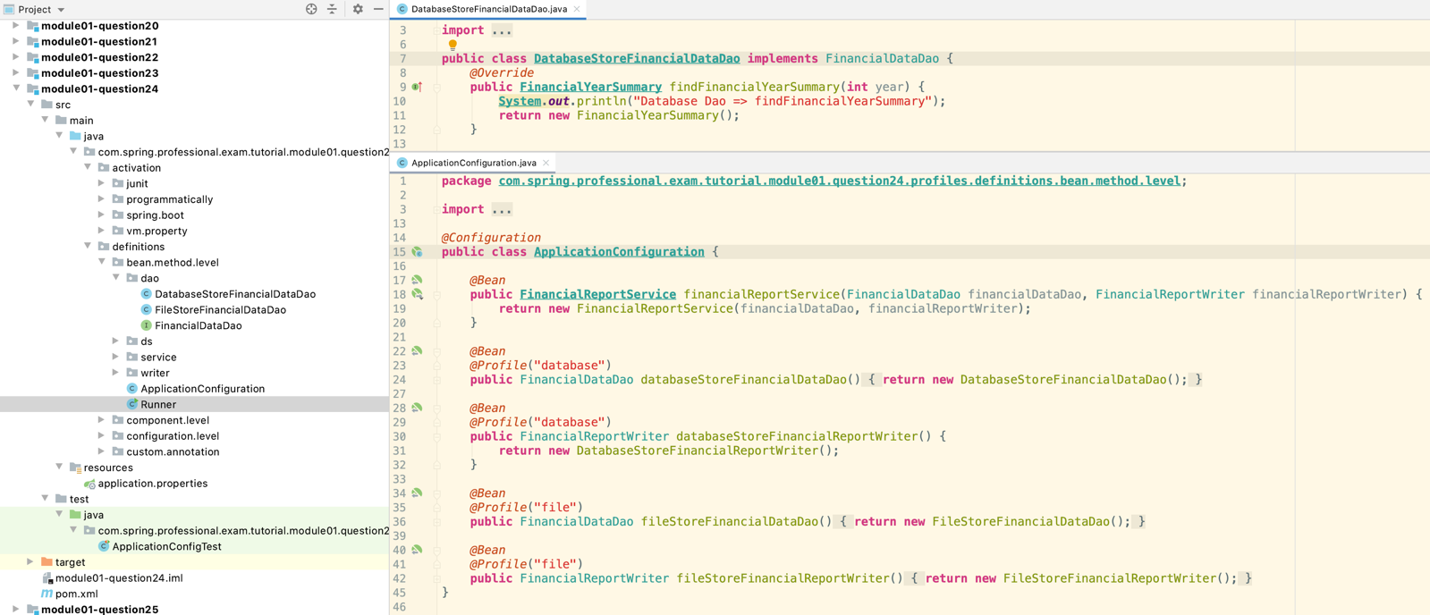

*  Use @Profile annotation to define custom annotation - @Component / @Configuration / @Bean method annotated with custom annotation will be part of profile/profiles specified in annotation

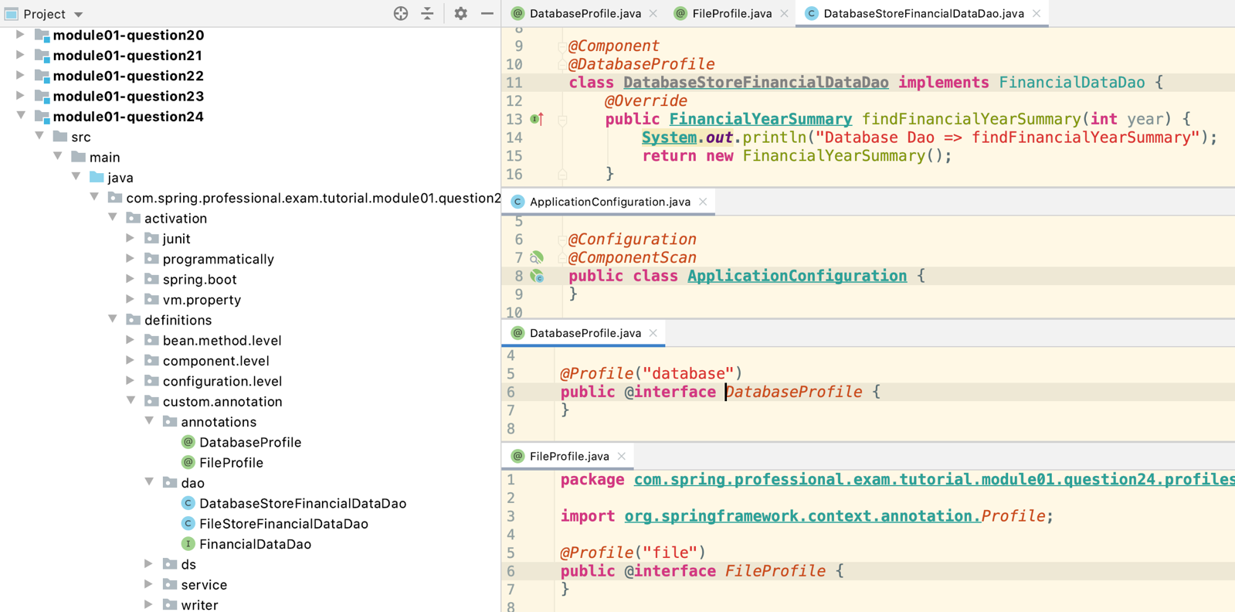

If Bean does not have profile specified in any way, it will be created in every profile.

You can use ‘!’ to specify in which profile bean should not be created.

You can activate profiles in following way:

*  Programmatically with usage of ConfigurableEnvironment
  + ontext.getEnvironment().setActiveProfiles("file");
*  By using spring.profiles.active property
  + *// profile should be activated with VM property -Dspring.profiles.active=database*
*  On JUnit Test level by using @ActiveProfiles annotation on Junit test
  + *@RunWith*(**SpringJUnit4ClassRunner**.**class**)  
    *@ContextConfiguration*(classes = **ApplicationConfig**.**class**)  
    *@ActiveProfiles*("database")  
    **public class ApplicationConfigTest** {  
     *@Autowired* **private** FinancialDataDao financialDataDao;  
      
     *@Test* **public void** shouldTestFinancialDataDao() {  
     **System**.***out***.println("Will perform test on " + financialDataDao.getClass().getSimpleName());  
     }  
    }
*  In Spring Boot Programmatically by usage of SpringApplicationBuilder
  + *@SpringBootApplication***public class Runner implements** CommandLineRunner {  
      
     *@Autowired* **private** FinancialDataDao financialDataDao;  
      
     **public static void** main(**String**[] args) {  
     **new** SpringApplicationBuilder(**Runner**.**class**)  
     .profiles("database")  
     .run(args);  
     }  
      
     *@Override* **public void** run(**String**... args) **throws Exception** {  
     **System**.***out***.println(financialDataDao.getClass().getSimpleName());  
     }  
    }
*  In Spring Boot by application.properties or on yml level
  + *@SpringBootApplication***public class Runner implements** CommandLineRunner {  
      
     *@Autowired* **private** FinancialDataDao financialDataDao;  
      
     **public static void** main(**String**[] args) {  
     **SpringApplication**.*run*(**Runner**.**class**, args);  
     }  
      
     *@Override* **public void** run(**String**... args) **throws Exception** {  
     **System**.***out***.println(financialDataDao.getClass().getSimpleName());  
     }  
    }
  + In application.properties or application.yml -> **spring.profiles.active**=database

Spring Profiles are useful in following cases:

*  Changing Behaviour of the system in Different Environments by changing set of Beans that are part of specific environments, for example prod, cert, dev
*  Changing Behaviour of the system for different customers
*  Changing set of Beans used in Development Environment and also during Testing Execution
*  Changing set of Beans in the system when monitoring or additional debugging capabilities should be turned on

## 1.25 Question 25 – Can you use @Bean together with @Profile?

Yes, @Bean annotation can be used together with @Profile inside class annotated with @Configuration annotation on top of method that returns instance of the bean.

If, method annotated with @Bean does not have @Profile, that beans that this bean will exists in all profiles.

**public class Runner** {  
 **public static void** main(**String**[] args) {  
 **AnnotationConfigApplicationContext** context = **new** AnnotationConfigApplicationContext();  
 context.registerShutdownHook();  
  
 *// Activate profile* context.getEnvironment().setActiveProfiles("database", "prod");  
 context.register(**ApplicationConfiguration**.**class**);  
 context.refresh();  
  
 **System**.***out***.println(context.getBean(**DataMapper**.**class**).getClass().getSimpleName());  
 **System**.***out***.println(context.getBean(DataProcessor.**class**).getClass().getSimpleName());  
 **System**.***out***.println(context.getBean(DataReader.**class**).getClass().getSimpleName());  
 **System**.***out***.println(context.getBean(DataWriter.**class**).getClass().getSimpleName());  
 }  
}

You can specify one, multiple profiles, or profile in which bean should not exists:

*@Configuration***public class ApplicationConfiguration** {  
  
 *@Bean // always created* **public DataMapper** dataMapper() {  
 **return new** DataMapper();  
 }  
  
 *@Bean  
 @Profile*({"database", "file"})  
 **public** DataProcessor multiSourceDataProcessor() {  
 **return new** MultiSourceDataProcessor();  
 }  
  
 *@Bean  
 @Profile*("database")  
 **public** DataReader dbDataReader() {  
 **return new** DbDataReader();  
 }  
  
 *@Bean  
 @Profile*("file")  
 **public** DataReader fileDataReader() {  
 **return new** FileDataReader();  
 }  
  
 *@Bean  
 @Profile*("!prod")  
 **public** DataWriter devDataWriter() {  
 **return new** DevDataWriter();  
 }  
  
 *@Bean  
 @Profile*("!dev")  
 **public** DataWriter prodDataWriter() {  
 **return new** ProdDataWriter();  
 }  
}

## 1.26 Question 26 – Can you use @Component together with @Profile?

Yes, @Profile annotation can be used together with @Component on top of class representing spring bean.

If, class annotated with @Component does not have @Profile, that beans that this bean will exists in all profiles.

You can specify one, multiple profiles, or profile in which bean should not exists:

*@Component  
@Profile*("!dev")  
**public class ProdDataWriter implements** DataWriter {  
}

*@Component  
@Profile*({"database", "file"})  
**public class MultiSourceDataProcessor implements** DataProcessor {  
}

## 1.27 Question 27 – How many profiles can you have?

Spring Framework does not specify any explicit limit on number of profiles, however since some of the classes in Framework, like ActiveProfilesUtils used by default implementation of ActiveProfilesResolver are using array to iterate over profiles, this enforces inexplicit limit that is equal to maximum number of elements in array that you can have in Java, which is Integer.MAX_VALUE - 2,147,483,647 (231 − 1).

**public class Runner** {  
 **public static void** main(**String**[] args) {  
 **AnnotationConfigApplicationContext** context = **new** AnnotationConfigApplicationContext();  
 context.registerShutdownHook();  
  
 *// Generate a large number of profiles  
 generateProfiles*(10000000).forEach(  
 p -> context.getEnvironment().addActiveProfile(p)  
 );  
 context.register(**ApplicationConfiguration**.**class**);  
 context.refresh();  
  
 **System**.***out***.println("Number of Profiles = " + context.getEnvironment().getActiveProfiles().length);  
 **System**.***out***.println("Bean on Profile Profile-9999999 = " + context.getBean(**SpringBean**.**class**).getClass().getSimpleName());  
 }  
  
 **private static List**<**String**> generateProfiles(**int** numberOfProfiles) {  
 **return IntStream**.*range*(0, numberOfProfiles)  
 .mapToObj(i -> **String**.*format*("Profile-%d", i))  
 .collect(**Collectors**.*toList*());  
 }  
}

*@Component  
@Profile*("Profile-9999999")  
**public class SpringBean** {  
}

## 1.28 Question 28 – How do you inject scalar/literal values into Spring beans?

To inject scalar/literal values into Spring Beans, you need to use @Value annotation.

@Value annotation has one field value that accepts:

*  Simple value
*  Property reference
*  SpEL String

@Value annotation can be used on top of:

*  Field
*  Constructor Parameter
*  Method – all fields will have injected the same value
*  Method parameter – Injection will not be performed automatically if @Value is not present on method level or if @Autowired is not present at method level
*  Annotation type

Inside @Value you can specify:

*  Simple value - @Value("John"), @Value("true")
*  Reference a property - @Value("${app.department.id}")
*  Perform SpEL inline computation - @Value("#{'Wall Street'.toUpperCase()}"), @Value("#{5000 * 0.9}"), @Value("#{'${app.department.id}'.toUpperCase()}")
*  Inject values into array, list, set, map – need Conversion service.

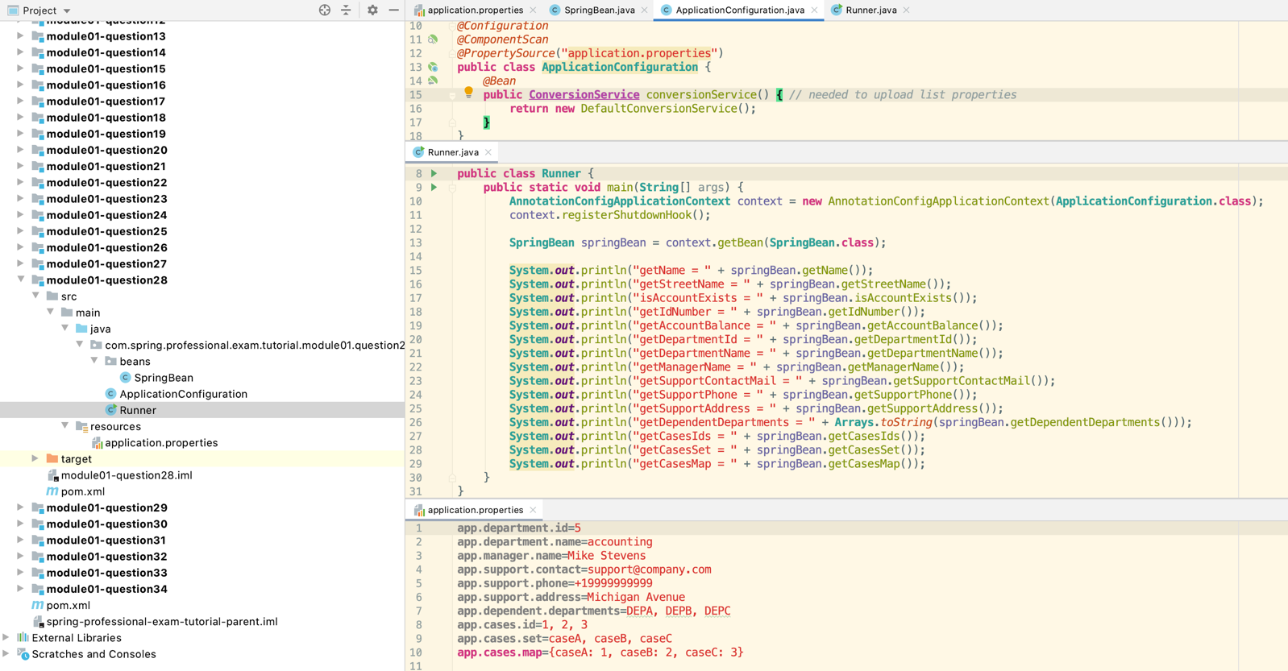

*@Component***public class SpringBean** {  
 *@Value*("John")  
 **private String** name;  
  
 *@Value*("#{'Wall Street'.toUpperCase()}")  
 **private String** streetName;  
  
 *@Value*("true")  
 **private boolean** accountExists;  
  
 *@Value*("100")  
 **private int** idNumber;  
  
 *@Value*("#{5000 * 0.9}")  
 **private float** accountBalance;  
  
 *@Value*("${app.department.id}")  
 **private int** departmentId;  
  
 *@Value*("#{'${app.department.id}'.toUpperCase()}")  
 **private String** departmentName;  
  
 **private String** managerName;  
  
 **private String** supportContactMail;  
  
 **private String** supportPhone;  
  
 **private String** supportAddress;  
  
 *@Value*("${app.dependent.departments}")  
 **private String**[] dependentDepartments;  
  
 *@Value*("${app.cases.id}")  
 **private List**<**Integer**> casesIds;  
  
 *@Value*("${app.cases.set}")  
 **private Set**<**String**> casesSet;  
  
 *@Value*("#{${**app.cases.map**}}")  
 **private Map**<**String**, **Integer**> casesMap;

// Constructor injection if of property  
 **public** SpringBean(*@Value*("#{'${app.manager.name}'.toUpperCase()}") **String** managerName) {  
 **this**.managerName = managerName;  
 }  
  
 *@Value*("${app.support.contact}")  
 **public void** setSupportContactMail(**String** supportContactMail) {  
 **this**.supportContactMail = supportContactMail;  
 }  
  
 *@Autowired* **public void** setSupportPhoneAndAddress(*@Value*("${app.support.phone}") **String** supportPhone, *@Value*("${app.support.address}") **String** supportAddress) {  
 **this**.supportPhone = supportPhone;  
 **this**.supportAddress = supportAddress;  
 }  
  
 **public String** getName() {  
 **return** name;  
 }  
// other getters deleted  
 }  
}

## 1.29 Question 29 – What is @Value used for?

@Value is used for:

*  Setting simple values of Spring Bean Fields, Method Parameters, Constructor Parameters
*  Injecting property/environment values into Spring Bean Fields, Method Parameters, Constructor Parameters
*  Injecting results of SpEL expressions into Spring Bean Fields, Method Parameters, Constructor Parameters
*  Injecting values from other Spring Beans into Spring Bean Fields, Method Parameters, Constructor Parameters
*  Injecting values into collections (arrays, lists, sets, maps) from literals, property/environment values, other Spring Beans
*  Setting default values of Spring Bean Fields, Method Parameters, Constructor Parameters when referenced value is missing

*@Component***public class SpringBean2** {  
 *@Value*("3")  
 **private int** taxId;  
  
 *@Value*("#{${**app.tax.value**}/100.0}")  
 **private float** taxValue;  
  
 *@Value*("${app.tax.department.name}")  
 **private String** taxDepartmentName;  
  
 *@Value*("${app.tax.department.alt.name:no_name}") //default parameter

**private String** taxDepartmentAlternateName

*@Component***public class SpringBean1** {  
 *@Value*("#{springBean2.taxId}") // reference from springBean2  
 **private int** taxId;

Can use environmental vars or vm options to set the default parameter: -Dapp.tax.department.alt.name="the tax dept"

## 1.30 Question 30 – What is Spring Expression Language (SpEL for short)?

Spring Expression Language (SpEL) is an expression language that allows you to query and manipulate objects graphs during the runtime. SpEL is used in different products across Spring portfolio.

SpEL can be used independently with usage of ExpressionParser and EvaluationContext or can be used on top of fields, method parameters, constructor arguments via @Value annotation @Value("#{ … }").

SpEL supported features:

* Literal expressions
*  Boolean and relational operators
*  Regular expressions
*  Class expressions
*  Accessing properties, arrays, lists, and maps
*  Method invocation
*  Relational operators
*  Assignment
*  Calling constructors
*  Bean references
*  Array construction
*  Inline lists
*  Inline maps
*  Ternary operator
*  Variables
*  User-defined functions
*  Collection projection
*  Collection selection
*  Templated expressions

Language Reference - <https://docs.spring.io/spring/docs/current/spring-frameworkreference/core.html#expressions-language-ref>

SpEL expressions are usually interpreted during runtime, this is good since it provides a lot of dynamic features. However, in some cases performance is more important than number of features available, for those cases Spring Framework 4.1 introduced possibility to compile expressions.

Compilation of Spring Expression is done by creating real Java Class that embodies expression, this results in much faster Expression Evaluation. Because during compilation, reference types of properties are unknown, Compiled Expressions are best to use when types of referenced types are not changing.

Compiler is turned off by default, you can turn it on by:

*  Parser Configuration
*  System Property - spring.expression.compiler.mode

Compiler can operation in three modes (SpelCompilerMode)

*  Off – default
*  Immediate – compile upon first expression interpretation
*  Mixed – compiler dynamically switched between interpreted and compiled mode, compiled form is generated after few invocations, if exception will be thrown during compiled form evaluation, then fallback to interpreted form will occur, and then after few invocation compiler will switch to compiled mode again

Compiled Mode does not support following expressions:

*  Expressions involving assignment
*  Expressions relying on the conversion service
*  Expressions using custom resolvers or accessors
*  Expressions using selection or projection

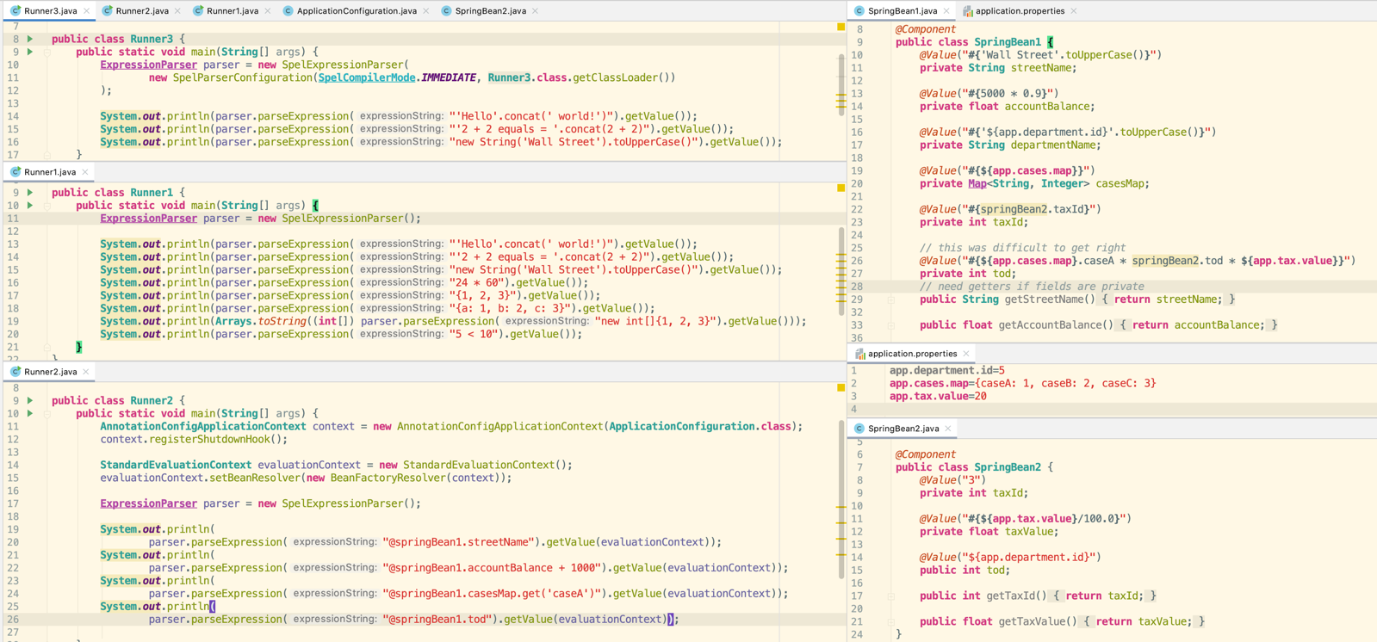

## 1.31 Question 31 – What is the Environment abstraction in Spring?

Environment Abstraction is part of Spring Container that models two key aspect of application environment:

*  Profiles
*  Properties

Environment Abstraction is represent on code level by classes that implements Environment interface. This interface allows you to resolve properties and also to list profiles. You can receive reference to class that implements Environment by calling EnvironmentCapable class, implemented by ApplicationContext. Properties can also be retrieved by using @Value("${…}") annotation.

Environment Abstraction role in context of profiles is to determine which profiles are currently active, and which are activated by default.

Environment Abstraction role in context of properties is to provide convenient, standarized and generic service that allows to resolve properties and also to configure property sources. Properties may come from following sources:

*  Properties Files
*  JVM system properties
*  System Environment Variables
*  JNDI
*  Servlet Config
*  Servlet Context Parameters

Default property sources for standalone applications are configured in StandardEnvironment, which includes JVM system properties and System Environment Variables. When running Spring Application in Servlet Environment, property sources will be configured based on StandardServletEnvironment, which additionally includes Servlet Config and Servlet Context Parameters, optionally it might include JndiPropertySource.

Too add additional properties files as property sources you can use @PropertySource annotation. userHome is @Value(“${user.home}”)

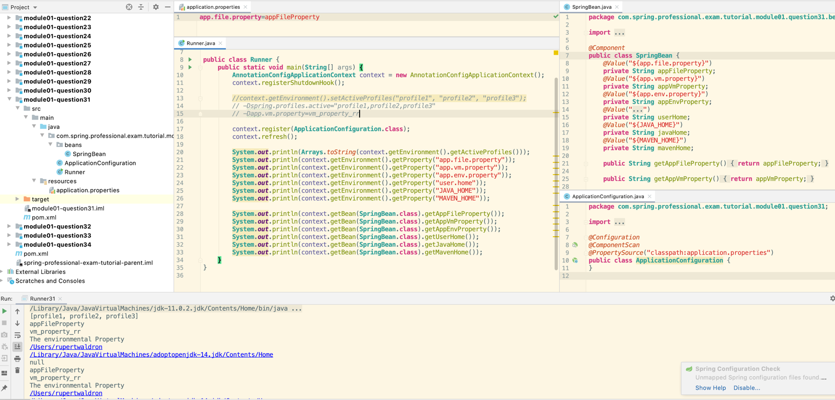

## 1.32 Question 32 – Where can properties in the environment come from – there are many sources for properties – check the documentation if not sure. Spring Boot adds even more.

Property Sources for Standalone Spring Framework Application: See question 31

*  Properties Files
*  JVM system properties
*  System Environment Variables

Property Sources for Servlet Container Spring Framework Application:

*  Properties Files
*  JVM system properties
*  System Environment Variables
*  JNDI
*  ServletConfig init parameters
*  ServletContext init parameters

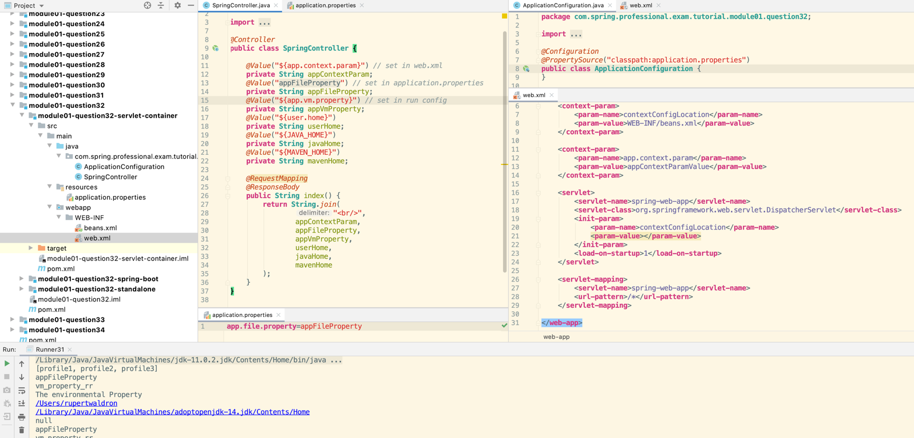

Property Sources for Spring Boot Application:

*  Devtools properties from ~/.spring-boot-devtools.properties (when devtools is active)
*  @TestPropertySource annotations on tests
*  Properties attribute in @SpringBootTest tests
*  Command line arguments
*  Properties from SPRING_APPLICATION_JSON property
*  ServletConfig init parameters
*  ServletContext init parameters
*  JNDI attributes from java:comp/env
*  JVM system properties
*  System Environment Variables
*  RandomValuePropertySource - ${random.*}
*  application-{profile}.properties and YAML variants - outside of jar
*  application-{profile}.properties and YAML variants – inside jar
*  application.properties and YAML variants - outside of jar
*  application.properties and YAML variants - inside jar
*  @PropertySource annotations on @Configuration classes
*  Default properties - SpringApplication.setDefaultProperties

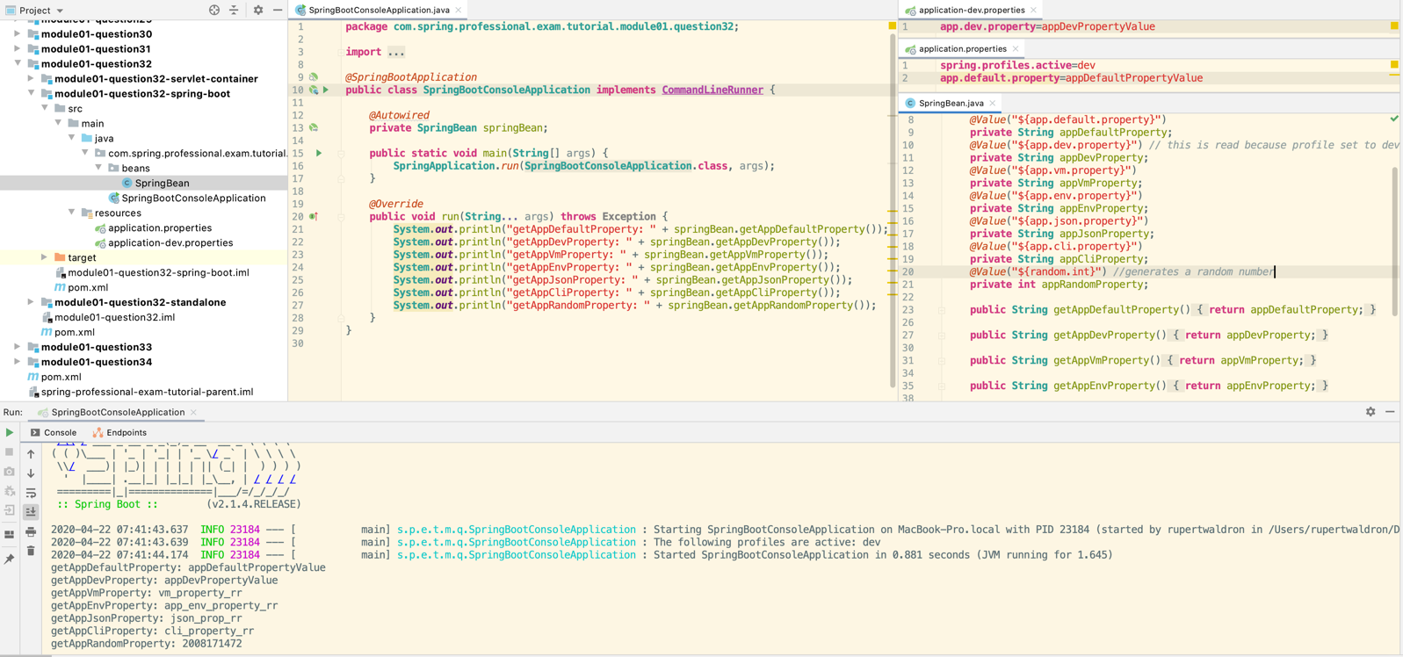

## 1.33 Question 33 – What can you reference using SpEL?

You can reference following using SpEL:

* Static Fields from class – T(com.example.Person).DEFAULT_NAME
* Static Methods from class – T(com.example.Person).getDefaultName()
* Spring Bean Property - @person.name
* Spring Bean Method - @person.getName()
* SpEL Variables - #personName
* Object property on reference assigned to SpEL variables - #person.name
* Object method on reference assigned to SpEL variables - #person.getName()
* Spring Application Environment Properties – environment[‘app.file.property’]
* System Properties – systemProperties[‘app.vm.property’]
* System Environment Properties – systemEnvironment[‘JAVA_HOME’]

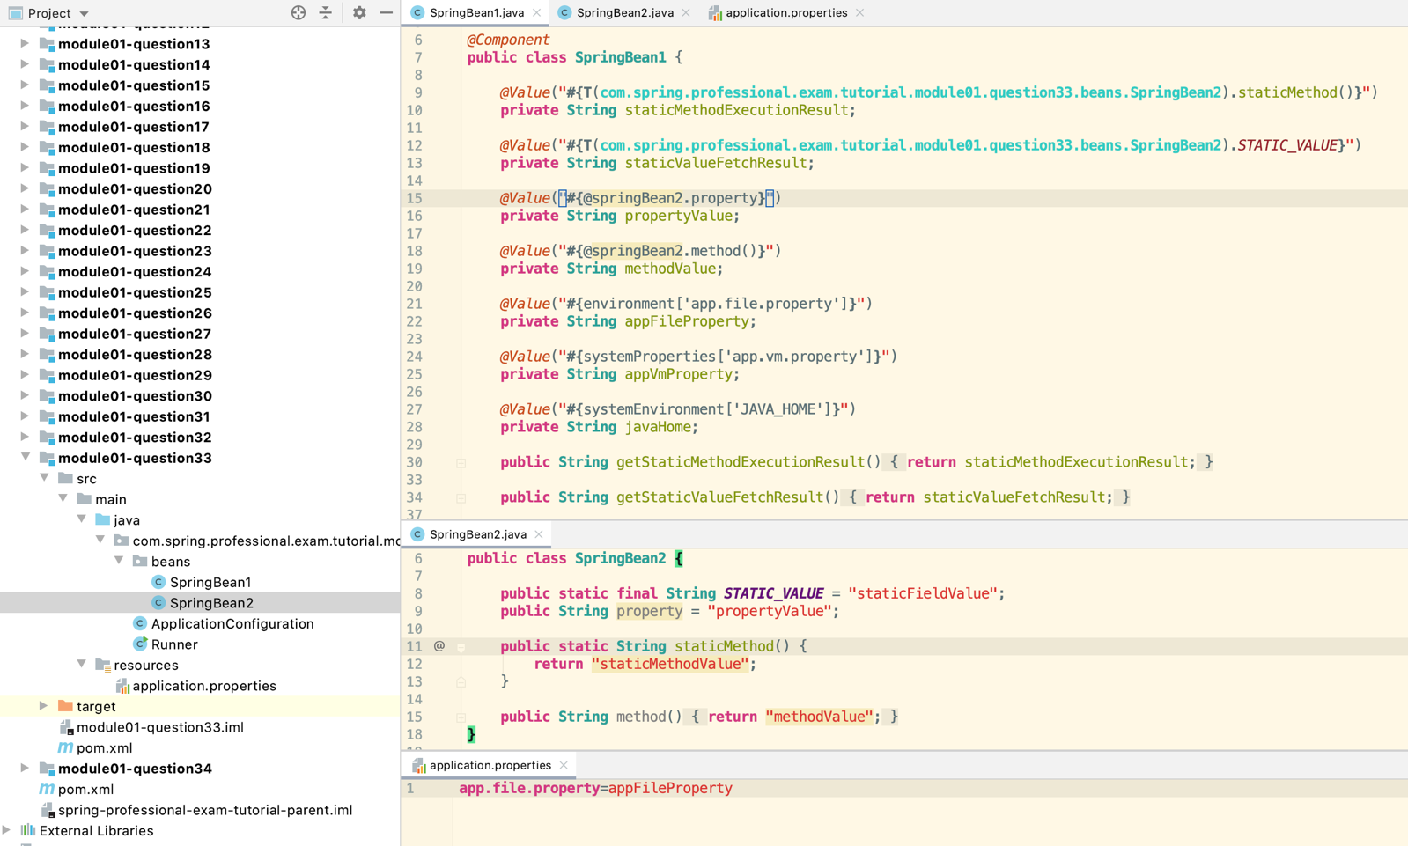

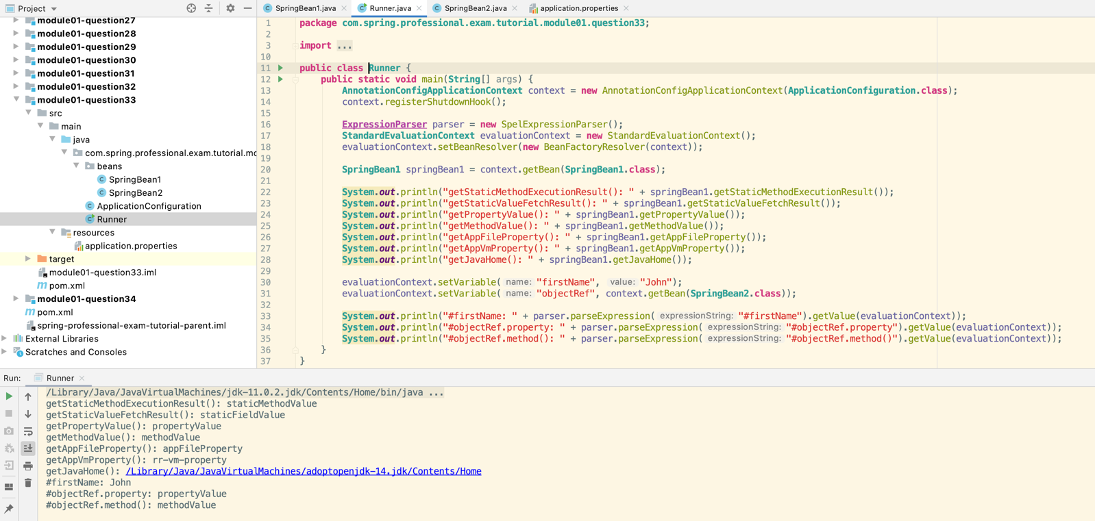

## 1.34 Question 34 – What is the difference between $ and # in @Value expressions?

@Value annotation supports two types of expressions:

*  Expressions starting with $ - used to reference a property in Spring Environment Abstraction
*  Expressions starting with # - SpEL expressions parsed and evaluated by SpEL

